Let’s Face it! Calculation Sheet
Label Prism  (use the value of the cards) | Area of Front  and Back | Area of Sides | Area of Top & Bottom | Total  Surface Area
Example:  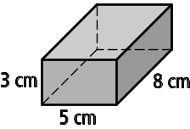 | 2 × (5 × 3)  = 2 × 15  = 30 cm² | =2 × (8 × 3)  = 2 × 24  = 48 cm² | 2 × (5 × 8)  = 2 × 40  = 80 cm² | 30 + 48 + 80  = 158 cm²


