Chapter 4 Crossword Puzzle Answer

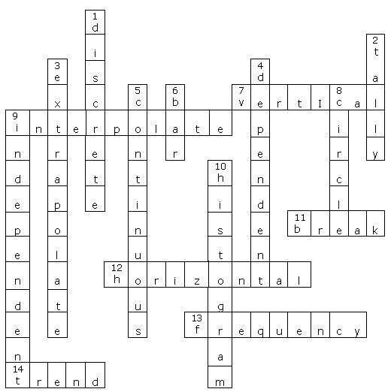

Across
7. vertical
9. interpolate
11. break
12. horizontal
13. frequency
14. trend

Down
1. discrete
2. tally
3. extrapolate
4. dependent
5. continuous
6. bar
8. circle
9. independent
10. histogram

