Chapter 7 Crossword Puzzle Answer

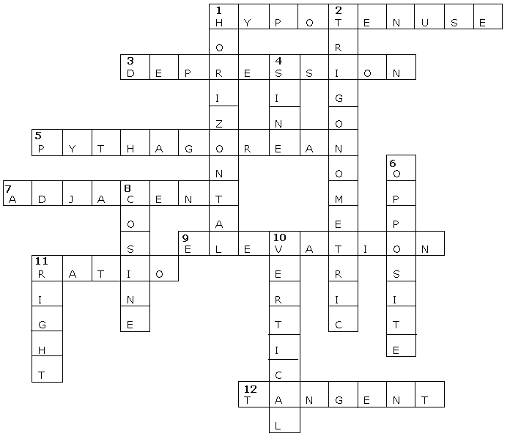
Across
1. hypotenuse
3. depression
5. Pythagorean
7. adjacent
9. elevation
11. ratio
12. tangent

Down
1. horizontal
2. trigonometric
4. sine
6. opposite
8. cosine
10. vertical
11. right

