Chapter 1 Riddle

circle | cone | cube | cylinder
diameter | dimensions | formula | height
length | net | pyramid | radius
rectangle | rectangular prism | slant height | sphere
square | surface area | triangle | triangular prism
width

Riddle: Why didn’t Mrs. Rectangular Prism want to hang out with Mr. Cube?

To find out, identify the object or object part shown in each visual. Write the correct term in the blank provided. Move the circled letters to the blank answer at the end of the puzzle.
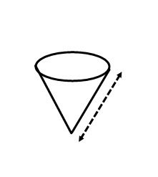
1.  1  ___ ___ ___ ___  9  ___ ___ ___ ___ ___ | 2.  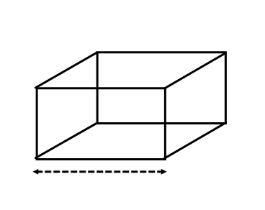  5  ___ ___ ___ ___ ___
3.  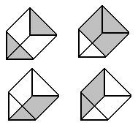  15  ___ ___ ___ ___ ___ ___  ___ ___ ___ ___ | 4.  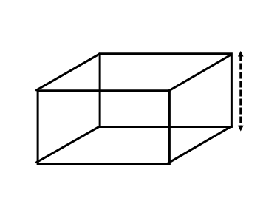  2  ___ ___ ___ ___ ___

5.  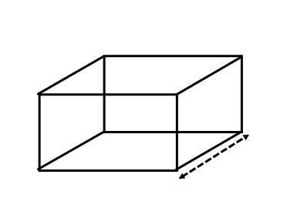  13  ___ ___ ___ ___ |  |  | 6.  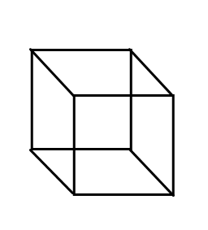  7  ___ ___ ___
7.  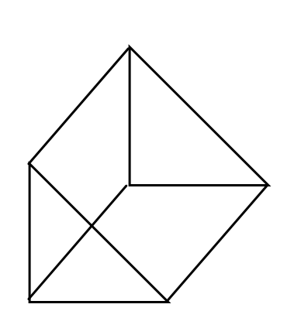  8  ___ ___ ___ ___ ___ ___ ___ ___ ___  ___ ___ ___ ___ ___ |  |  | 8.  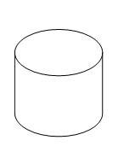  12  ___ ___ ___ ___ ___ ___ ___
9.  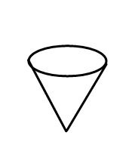  6  ___ ___ ___ |  |  | 10.  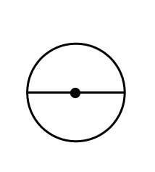  16 23  ___ ___ ___ ___ ___ ___
11.  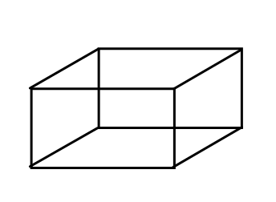  21  __ __ __ __ __ __ __ __ __ __  19  __ __ __ | 12.  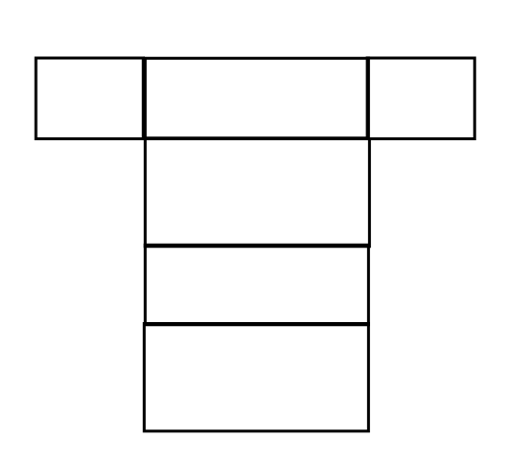  4  ___ ___
13.  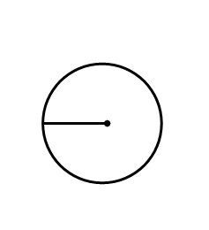  14  ___ ___ ___ ___ ___ |  | 14.  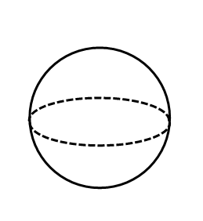  11  ___ ___ ___ ___ ___
5.  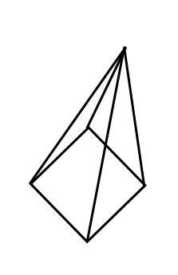  22  ___ ___ ___ ___ ___ ___ |  | 16.  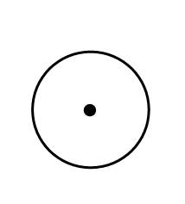  24  ___ ___ ___ ___ ___
17.  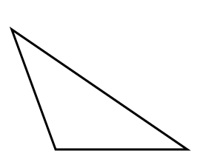  10  ___ ___ ___ ___ ___ ___ ___ |  | 18.  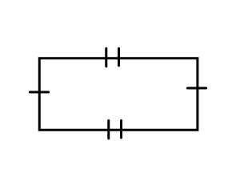  3  ___ ___ ___ ___ ___ ___ ___ ___
19.  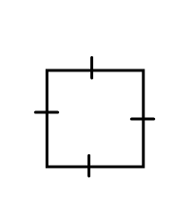  20  ___ ___ ___ ___ ___ |  | 20.  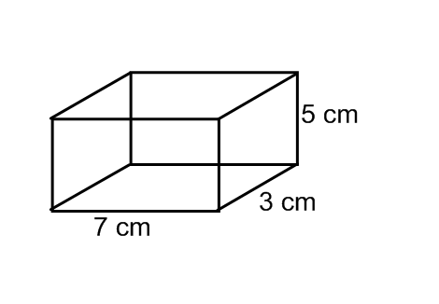  17  ___ ___ ___ ___ ___ ___ ___ ___ ___
21.
SA = 2lw + 2wh + 2lh

18
___ ___ ___ ___ ___ ___

Riddle Answer:

___ ___ ___ ___ ___ ___ ___ ___ ___ ___ ___ ___ ___ ___ ___
1 2 3 4 5 6 7 8 9 10 11 12 13 14 15

___ ___ ___ ___ ___ ___ ___ ___ ___
16 17 18 19 20 21 22 23 24

