Converting Test Banks From Logic eXtension Resources (LXR) is to ExamView®

Step 1: Open the LXR test bank.
Select the question type to be exported, for example, Multiple Choice. It is simplest to export each question type separately. The entire bank can be converted, but this will require additional formatting of the bank before importing into ExamView®.

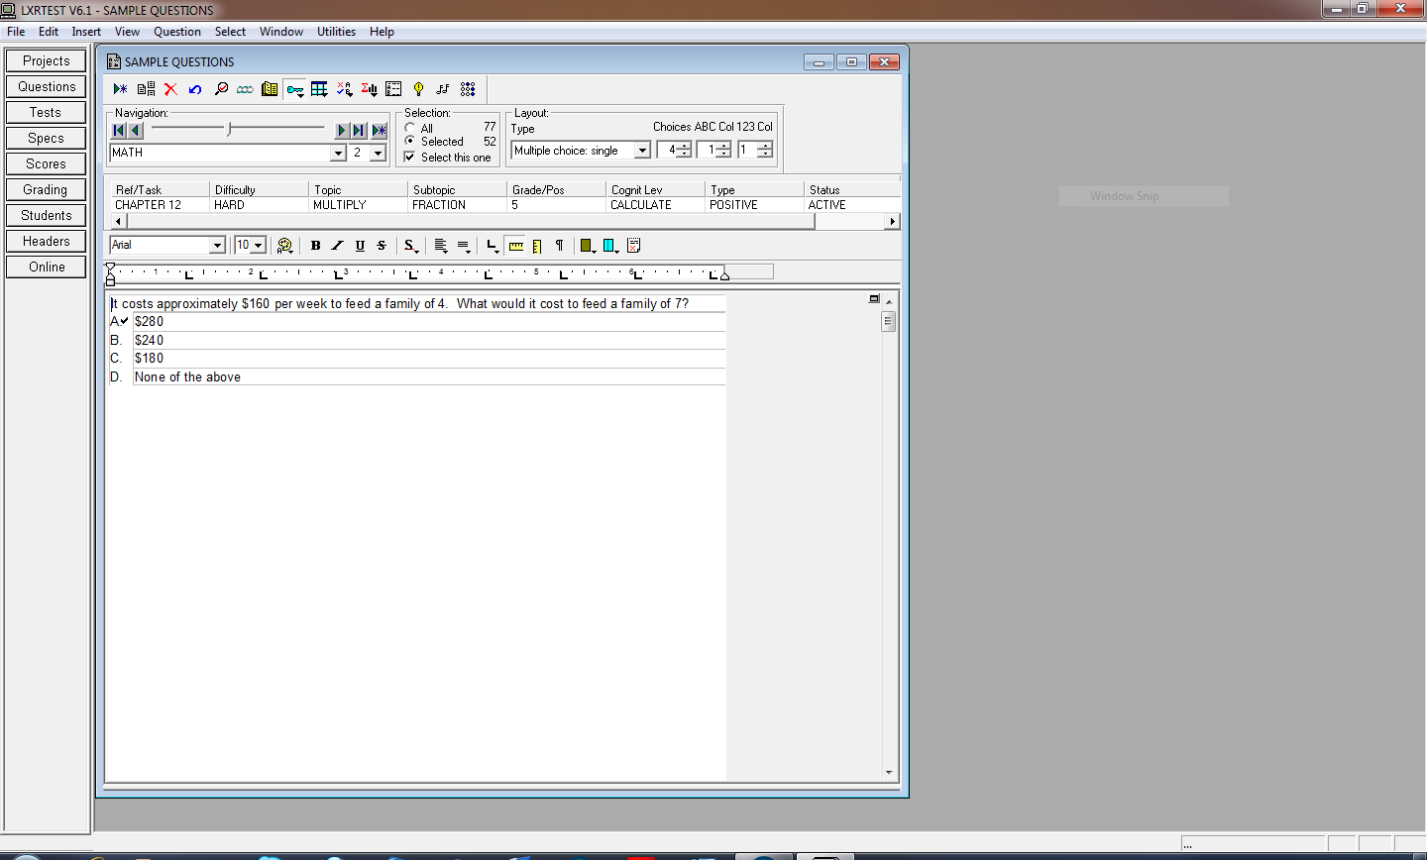

Step 2: Export the selected LXR test bank as a text file.
Select “Export” from the “File” menu. This will give you the following screen:

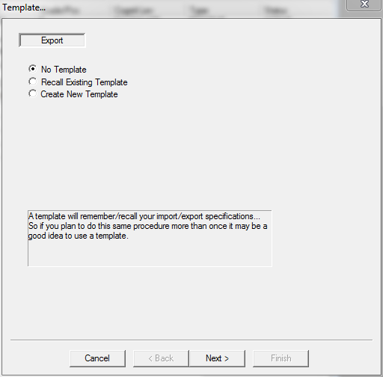
Make sure the “No Template” option is selected. Click “Next.” This will give you the following screen:
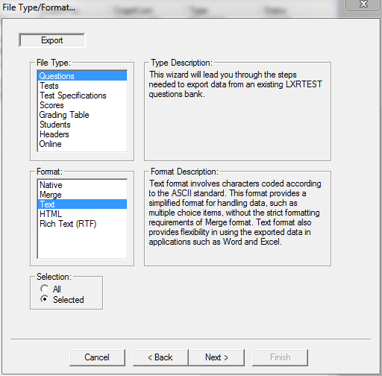

Under “File Type” select “Questions,” and under “Format” select “Text,” as shown above. Click “Next” to bring up the screen that asks you where you wish to save the exported file.

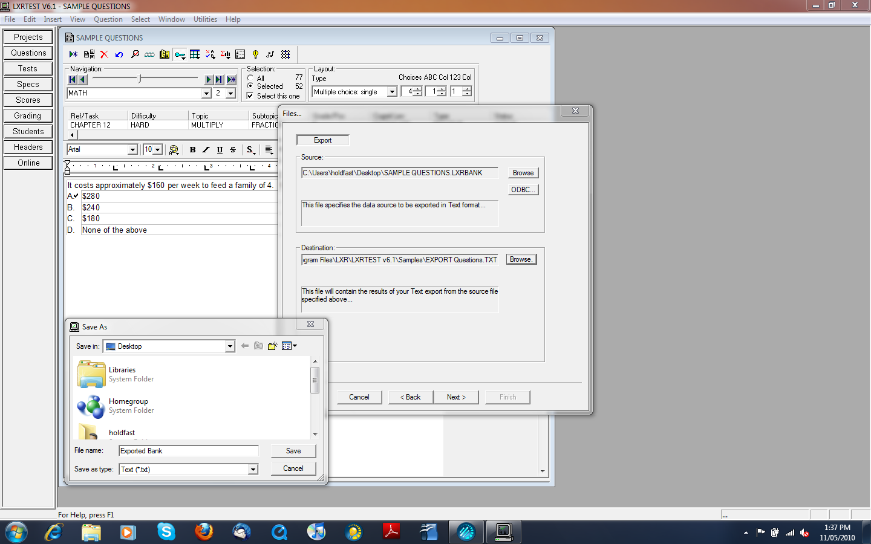

Navigate to the desired location and click “Next.” When the following screen comes up, ensure that the “Field delimiter” option is set to “Return/LineFeed” and the “Record delimiter” option is set to “Double Return/LineFeed.”
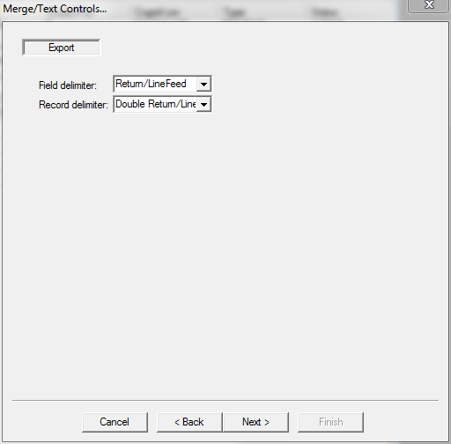

When the “Fields…” screen comes up, select “Contents (Stem and Choices)” and “Answer,” and then click “Next.”

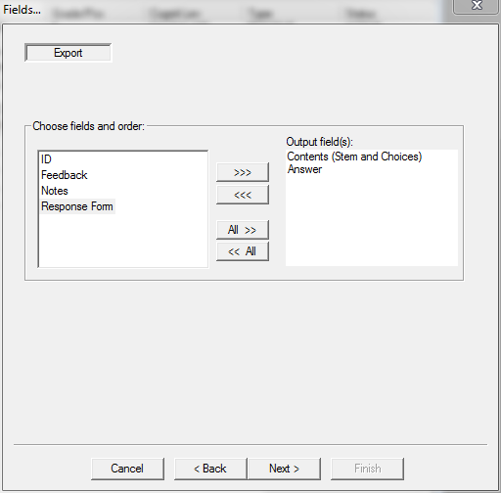

Select “Finish” to export the test bank as a text file:
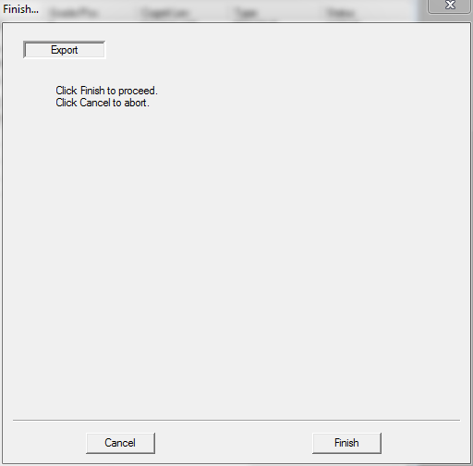

Step 3: Format the exported text file.
Open the text file you just exported in a word-processing program. Select “Find and Replace” from the “Edit” menu. Type in “Answer” in the “Search for” field and “ANS” in the “Replace with” field. Click “Replace.” Check each use of “Answer” as it comes up. Make sure that you are replacing only the Answer: field and not the word “answer” that may come up in an occasional question
When ExamView® imports the text file it will look for the question answer after it sees “ANS.” If the above change is not done, the import will not work.

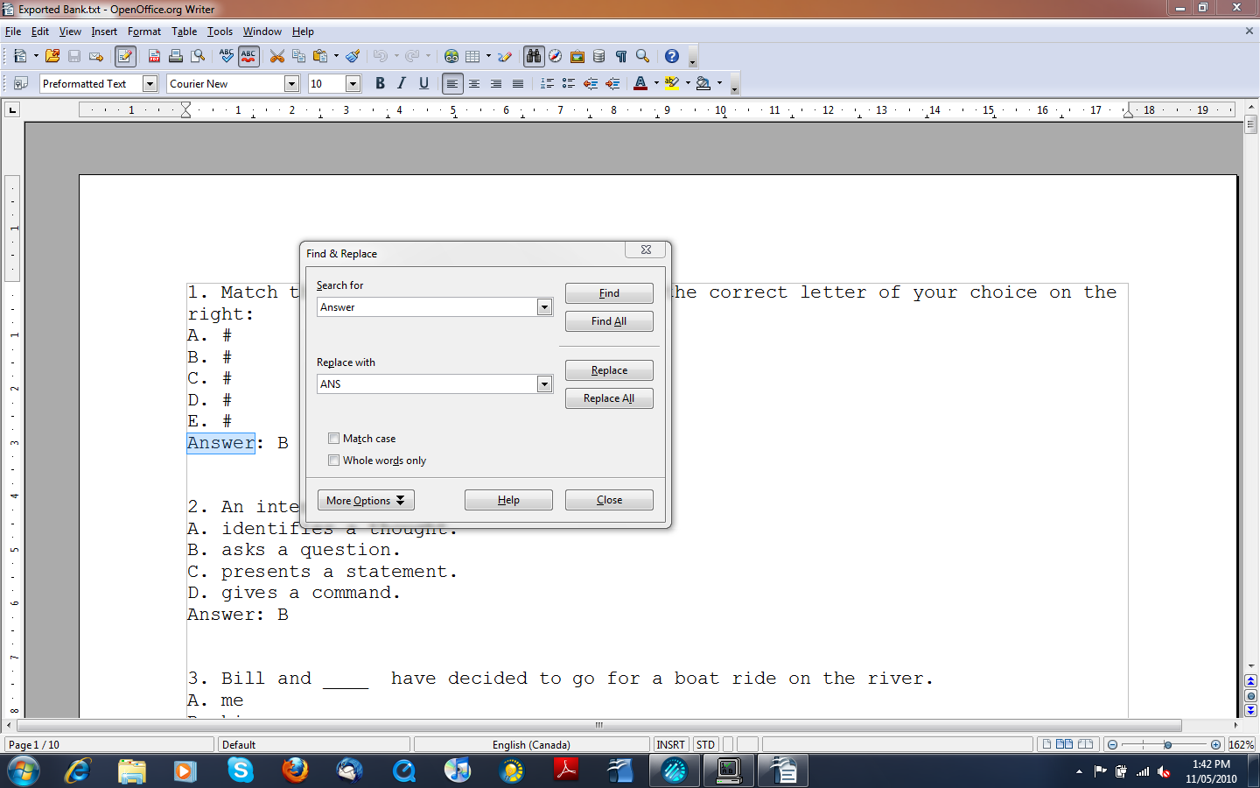

Add the label “MULTIPLE CHOICE” at the beginning of the text file. When formatting text files with other question types, make sure you use the question types that correspond to those used in ExamView® (i.e., COMPLETION, MATCHING, SHORT ANSWER, and PROBLEM).

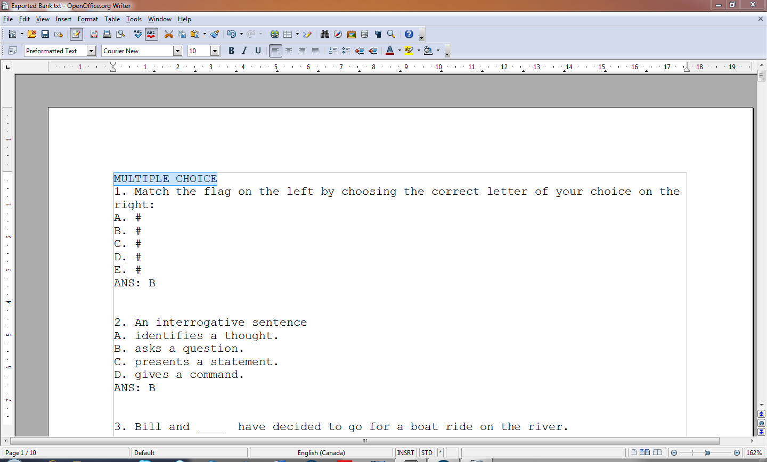

Graphics in the LXR questions that have been exported to a text file will have to be inserted into the corresponding ExamView® bank after the import process has been completed. Make sure you save the formatted text file before starting step 4.

Step 4: Import the formatted text file into ExamView®.
Open the ExamView® Import Utility that can be found in the ExamView® folder.

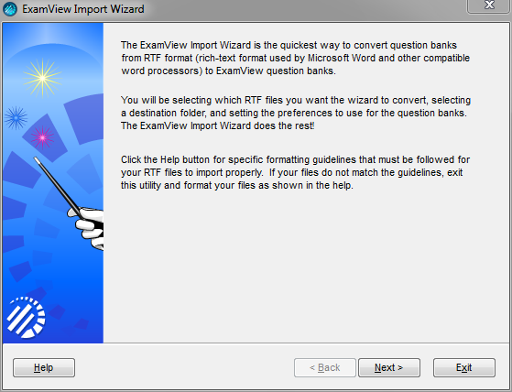
Select the text file you wish to import and then click “Next.”

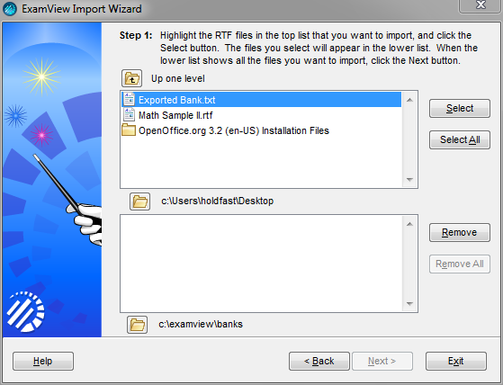

Set the “Default number of columns for multiple choice questions:” to “1.” Leave all other options selected as shown below, and then click “Next.”

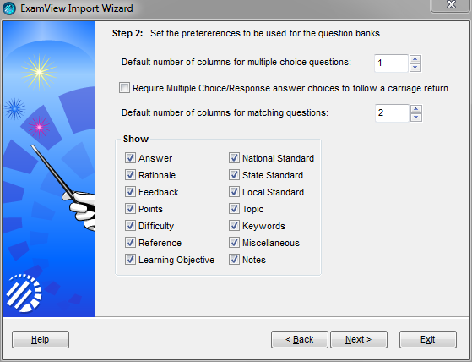

Ensure that the default options, as shown below, are selected, and then click “Next.”

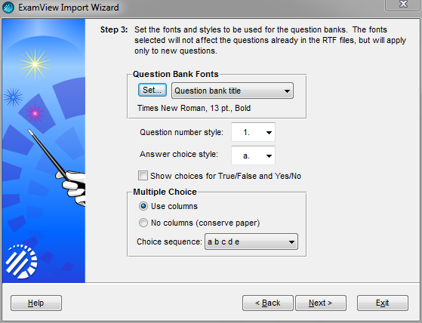

Click “Next” without changing any of the default settings.

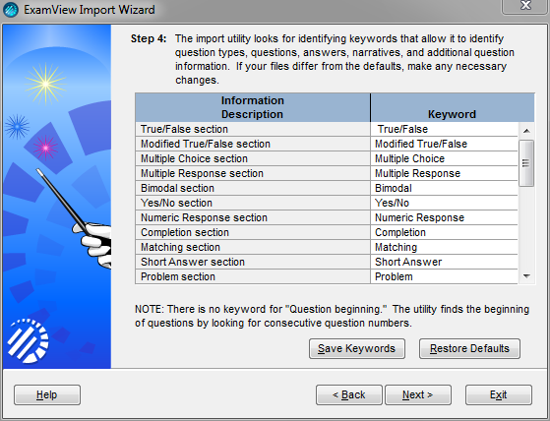
Click “Finish” to complete the import of the text file into ExamView®.

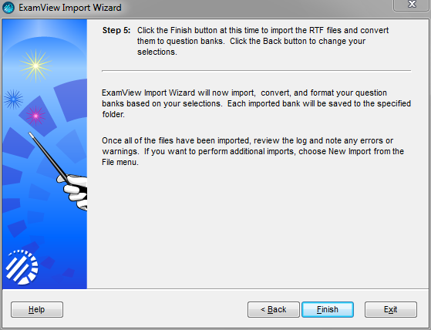

A successful import will result in a report similar to the one shown below.

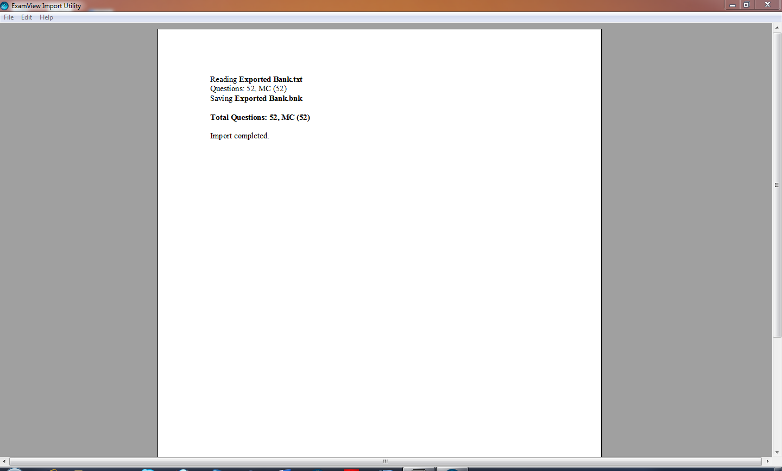

Open the newly imported bank using ExamView®.

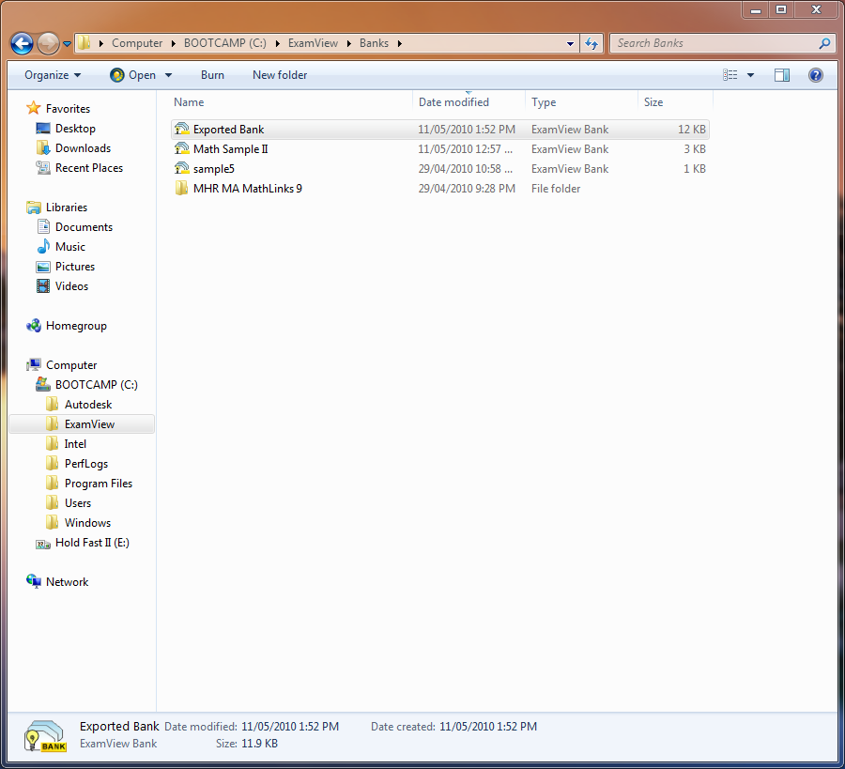

Add a title for the bank and import any missing graphics into the appropriate questions.

