Chapter 1 Prerequisite Skills

1. Fill in the blanks.
a) There are ______ centimetres in 1 m.
b) There are ______ millimetres in 1 m.
c) There are ______ millimetres in 3.5 m.
d) There are ______ centimetres in 1 km.
2. Estimate the total length of the line segment(s) connecting S and T. Then, measure to determine how close your estimates are to the actual measurements. Give your answers in centimetres.
a)
b) 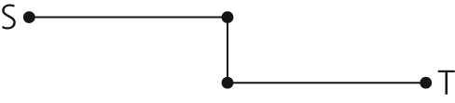
c) 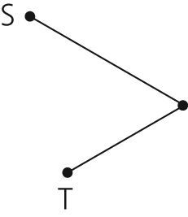
3. The diagram shows an SI ruler.
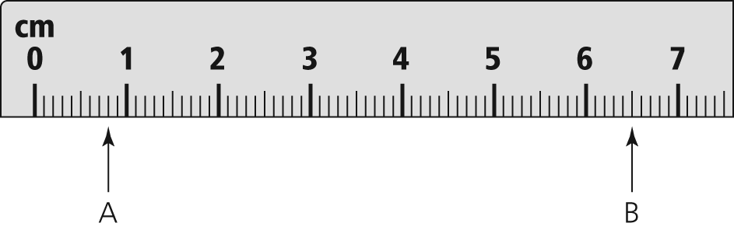
a) What is the length measured at A?
b) What is the distance from A to B?
c) What is the smallest unit you can read on this ruler?
4. Mark the position of each letter on the ruler.
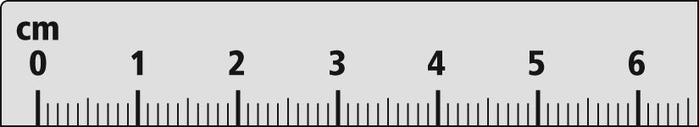

a) L = 1.7 cm b) M = 2.5 cm
c) N = 32.5 mm d) P = 55 mm
5. Suppose each diagram is drawn on centimetre grid paper. What is the shortest distance from A to B?
a) 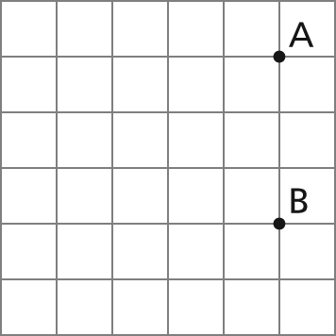
b) 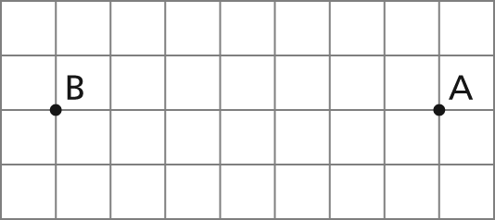
c) 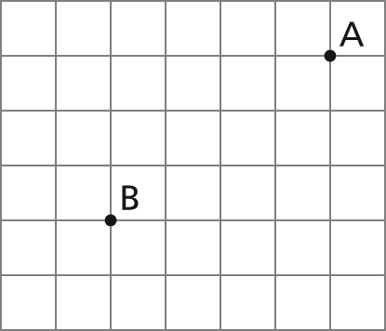
6. a) Describe the meaning of scale factor. Use an example.
b) Suppose the scale factor for a diagram of a digital camera is less than 1. Describe what you know about the diagram.
c) The diameter of a Canadian toonie is
28.03 mm. What scale was used to create the image shown? Express your answer in lowest terms, to the nearest hundredth.


7. What is the lowest common denominator for each set of fractions?
a) ,
b) , ,
c) ,
d) , ,
8. Simplify. Express your answer as a fraction and as a decimal.
– +
9. Solve each proportion for x. Explain how you determined your answer in part b).
a) =
b) =
c) =
d) =
10. What is the perimeter of each figure? Give each distance to the nearest hundredth of a unit, if necessary.
a) 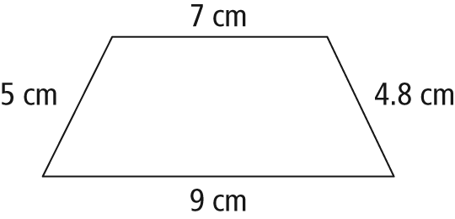
b) 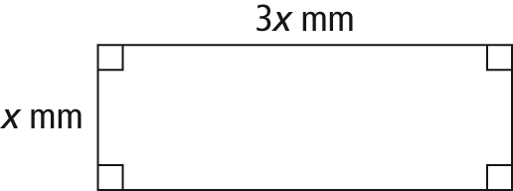

c) 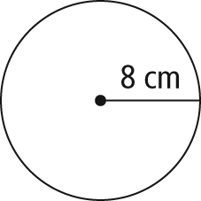
11. For each figure described, draw a labelled diagram to help you calculate the unknown distance. Express your answer to the nearest tenth of a metre.
a) Rectangle: perimeter = 16 cm
length of one side = 5 cm
length of other side =
b) Isosceles triangle: perimeter = 18.4 mm
length of equal sides = 5.6 mm
length of third side =
c) Circle: circumference = 18 m
diameter =

