Chapter 2 Prerequisite Skills

Show all your work.
1. Calculate the surface area and volume of each rectangular prism. Express the answer in centimetres and inches. Round your answer to the nearest tenth.
a)
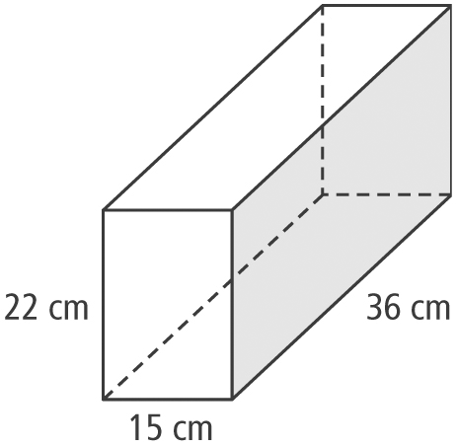

b)
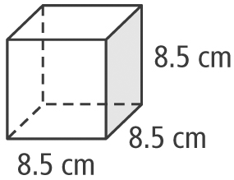

c)
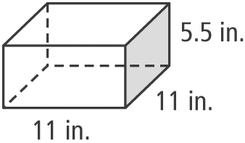

2. Calculate the surface area and volume of each cylinder. Express the answer in centimetres and inches. Round your answer to the nearest tenth.
a) 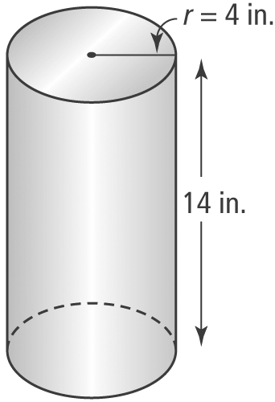
b) 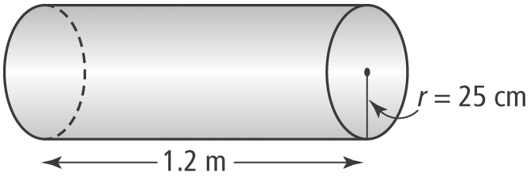
c) 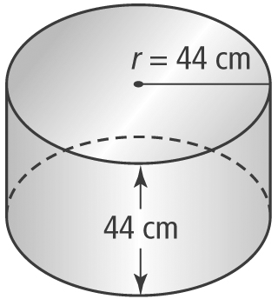
d)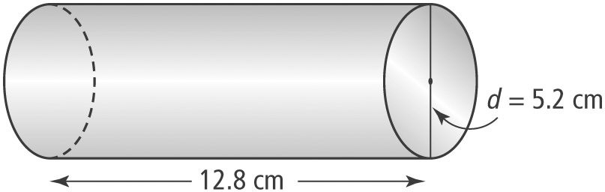
e) 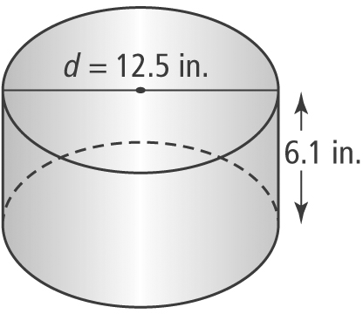
3. Use a sketch to help determine the surface area and volume of each 3-D object. Express your answer to the nearest tenth.
a) a cube with side length 14.3 cm
b) a rectangular prism measuring 3 in. by 6 in. by 4 in.
c) a rectangular prism measuring 0.85 m by
34.25 cm by 642 mm
d) a cylinder with height 62.8 cm and radius 11.3 cm
e) a cylinder with diameter 15 in. and height 3 ft
f) a cylinder with circumference 452 mm and height 1.65 m
4. Determine the square root of each number to the nearest hundredth.
a) 81
b) 30
c) 12
d) 65.98
e) 1589.04
5. a) A cube has a volume of 8 m³. Determine its side length.
b) What real object could this cube represent?
6. a) A cube has a volume of 125 cm³. Determine its side length.
b) What real object could this cube represent?

