Chapter 3 Prerequisite Skills

Show all your work.
1. Which angle has a measure of about 75°?
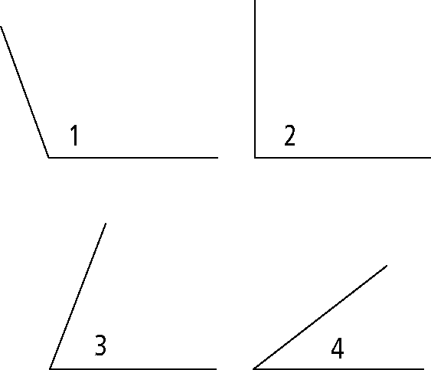
2. Estimate and measure each angle.
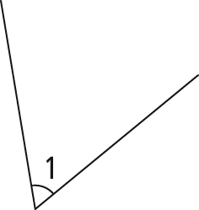 | 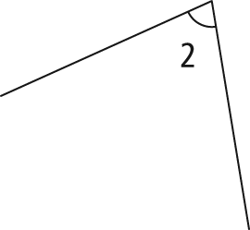
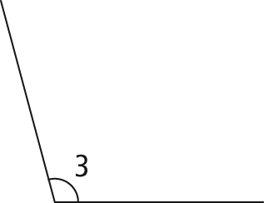 | 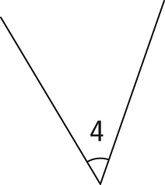
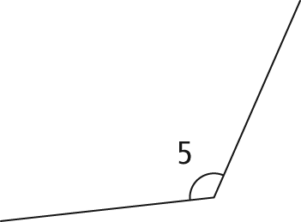

3. Draw an angle that you estimate has the given measure. Then, measure each of your angles to see how close your estimate is to the actual measure.
a) 30°
b) 65°
c) 90°
d) 130°
4. Sketch ΔEFG with ∠E = 90° and ∠F = 40°. Do not use a protractor. Label your sketch.

5. Consider ΔDEF with ∠D = 90° and
∠E = 50°:
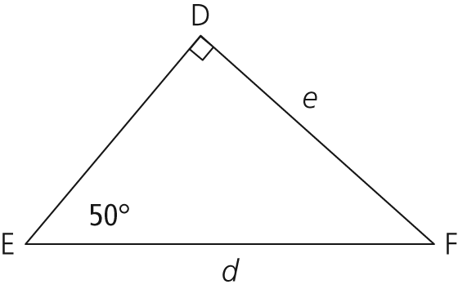
a) Name side DE another way.
b) What is the size of ∠F?
c) What is the shortest side of ΔDEF?
d) Name ∠F another way.
6. Right triangle PQR has the following properties:
- an angle of 30°
- the shortest side is labelled PQ
How many ways could you sketch and label the triangle? Explain.
7. For each right triangle, write a mathematical equation that demonstrates the Pythagorean relationship.
a) 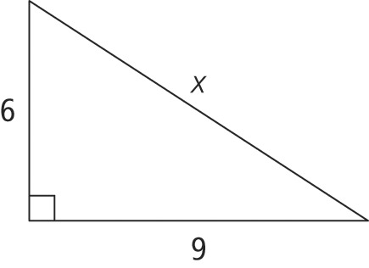
b) 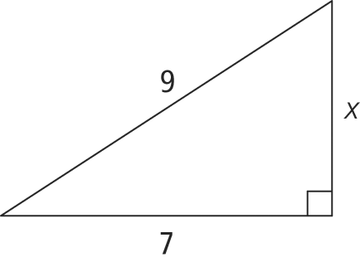
c) 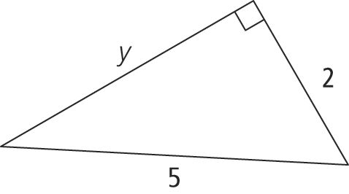
8. Solve for x.
a) 3x – 2 = 13
b) x² = 3² + 4²
c) 169 = x² + 25
9. Sort the following figures into sets so that all the figures in each set are similar. Explain your thinking.

10. ΔABC is similar to ΔDEF.
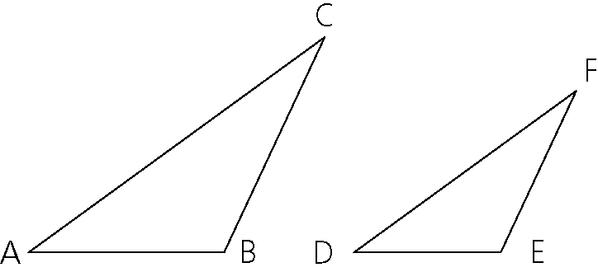
a) Show how the angles of the two triangles are related.
b) Which sides of the triangles are proportional? Explain what this means.
c) Complete the proportion to make a true statement: .
11. 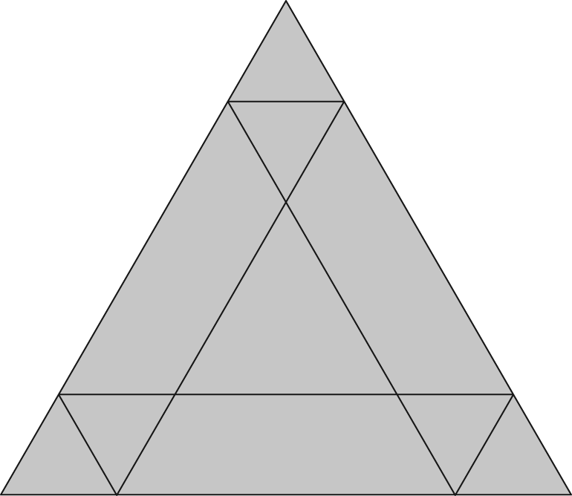
a) How many triangles are in the figure?
b) How many different triangles are in the figure?

