Chapter 5 Prerequisite Skills

Show all your work.
1. For each expression, identify
- the number of terms
- whether it is a monomial, binomial, trinomial, or polynomial
a) 3p²
b) (3x)(5y)
c) h + 2h² – 3
d) 2x² – 4x + 6
2. What expression is represented by each set of algebra tiles? Shaded tiles are positive and white tiles are negative.
a)
b) 
c) 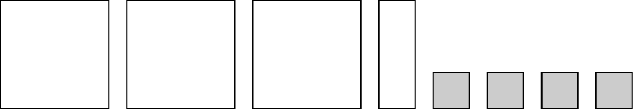
3. Determine each product. Use a model if necessary.
a) (–2x)(4.5x)
b)
c)
4. Determine each quotient. Use a model if necessary.
a)
b)
c)
5. A rectangle is five times as long as it is wide. If the area of the rectangle is 12 500 cm², what are its dimensions? Use a diagram to help you.

6. A square has side lengths of 2s. A circle has a diameter that is the same length as the sides of the square. What is the ratio of the areas of the two shapes?
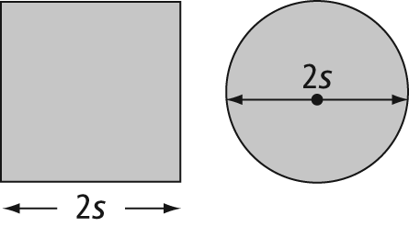
7. Expand.
a) (2x)(3x – 1) b) (–4k + 1)(–5k)
c) (6x) d) (3.6p – 1.2)
8. Divide.
a)
b)
c)
9. The area of a trapezoid is given by the formula A = where a is the altitude and b₁ and b₂ are the bases of the trapezoid. What is an expression for the area of the following trapezoid?
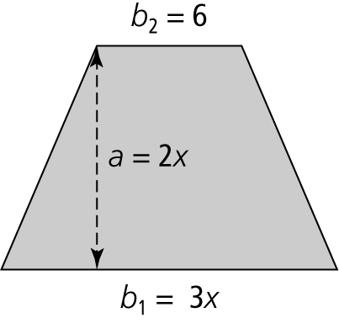
10. A rectangle has an area of 15v² − 12v square units. The width of the rectangle is 3v units. What is the length of the rectangle?
