Chapter 9 Prerequisite Skills

Show all your work.

1. Write each equation in the form y = mx + b.
a) 3y = 6x + 15
b) 2x – 5y = 7
c) –4x + y – 3 = 0
2. When you double Carole’s age and add 10, you get her mother’s age. Write a mathematical expression that shows the mother’s age. Tell what your variable represents.
3. The following chart reveals the number of circles in a pattern.

Term Number | 1 | 2 | 3 | 4
Number of Circles | 1 | 3 | 5 | 7
a) How many circles would exist for term number 5?
b) Write a mathematical expression that would allow you to determine the number of circles for any term.
4. The diagram shows a pattern of small squares.
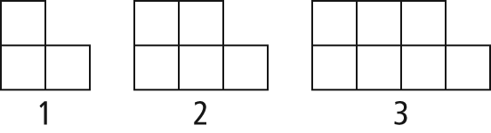
a) Construct a chart showing the term number and the increasing number of small squares in the pattern.
b) How could you determine the number of small squares in the seventh term?
c) Write an algebraic expression showing the total number of small squares, where t represents the term number.
5. Write a mathematical expression for each of the following.
a) a number, t, decreased by 5
b) the number of almonds in a bowl after you add a dozen
c) your brother’s age, if he is ten years older than half your age
6. Complete the following chart using the rule “the number of small squares is the product of 4 and the sum of the term number and 1.”

Term Number | 1 | 2 | 3 | 8
Number of Squares
7. The following chart reveals the number of triangles in an increasing pattern.

Term Number, x | 1 | 2 | 3 | 4
Number of Triangles, y | 1 | 5 | 9 | 13
a) Write a mathematical expression for the number of triangles.
b) Draw a graph showing the pattern in the chart.
8. Consider a line with the equation
6x – 2y = 8.
a) Draw a graph of this line.
b) If you multiplied both sides of the equation by 3, would the graph change? Explain.
c) If you divided both sides of the equation by 2, would the graph change? Confirm your answer by drawing a new graph for the divided equation.
d) Would the graph change if you divided by a negative value?
e) Create a rule for how the line on a graph changes when you multiply or divide both sides of the equation by the same value.
9. For a specific van, the ground clearance of the rear bumper is given by the formula
. The clearance, in centimetres, is c, and the mass of the load, in kilograms, is m.
a) Determine c when m = 200 kg.
b) What is the value of c when
m = 450 kg?
c) If the van is carrying a load of 600 kg, will the bumper clear a curb that is 18 cm high? Justify your answer.
d) What is the minimum mass that would cause the bumper of the van to touch the ground?


