Chapter 1 Prerequisite Skills Answers

BLM 1–2 Chapter 1 Prerequisite Skills
1. a) 100 b) 1000 c) 3500 d) 100 000
2. a) 5.2 cm b) 4.2 cm c) 3.2 cm
3. a) 0.8 cm or 8 mm b) 5.7 cm or 57 mm c) 1 mm
4. 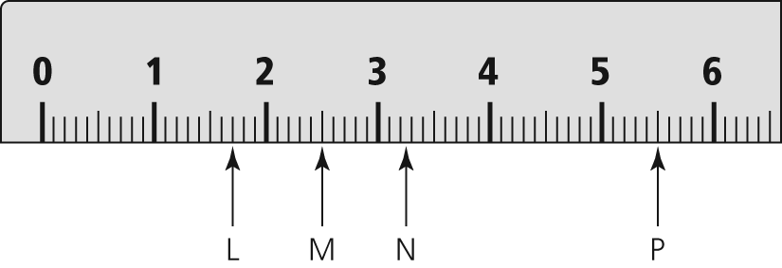
5. a) 3 cm b) 7 cm c) 5 cm
6. a) Scale factor refers to the constant factor by which all dimensions of an object are enlarged or reduced in a scale drawing. For example, if the dimensions of a drawing of a square are enlarged by a factor of 2, then each side of the square is 2 times as long as the original.
b) If the scale factor is less than 1, the diagram is a reduction.
c) 1:1.45
7. a) 8 b) 16 c) 8 d) 32
8. = 0.625
9. a) x = 10 b) x = 7.5. Example: If you look at the numerators, you can see that you can get from 2 to 3 by multiplying by 1.5. Then, you do the same with the denominators.
c) x = 1.25 d) x = 22.5
10. a) 25.8 cm b) 8x mm c) 50.27 cm
11. a) 3 cm 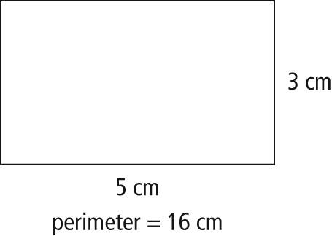
b) 7.2 mm 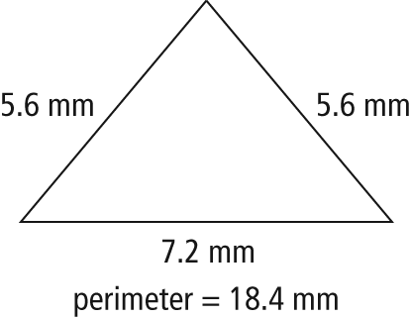
c) 5.7 m 