Chapter 3 Prerequisite Skills Answers

BLM 3−2 Chapter 3 Prerequisite Skills
1. ∠3
2. Example: ∠1 = 60°, ∠2 = 75°,
∠3 = 105°, ∠4 = 50°, ∠5 = 120°
3. Example:

a)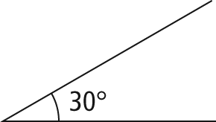 | b) 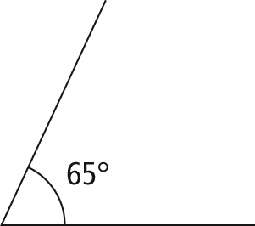
c) 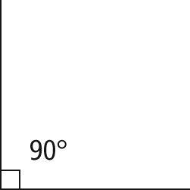 | d) 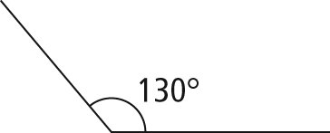
4. 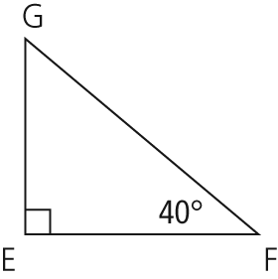

5. a) side f b) 40° c) side f d) ∠EFD or ∠DFE
6. The triangle could be sketched in two ways. The shortest side, PQ, is opposite the smallest angle. As a result, the 30° angle is labelled R in both sketches. However, side PQ could be labelled with either the P or the Q at the right angle.
7. a) x² = 6² + 9² b) x² = 9² − 7² or 9² = x² + 7²
c) y² = 5² − 2² or 5² = y² + 2²
8. a) x = 5 b) x = 5 c) x = 12
9. Sets can be arranged in several ways. Possible explanations include
- arranged by shape (circles, rectangles, and triangles)
- arranged by size (small and large)
- arranged by orientation (horizontal/vertical and rotated)
- arranged as “similar figures” mathematically (two circles, two right triangles, two equilateral triangles, or the two rectangles where the length is slightly more than twice the width)
10. a) and ∠A = ∠D,
∠B = ∠E, and ∠C = ∠F
b) AB : DE, AC : DF, and BC : EF c) x = AC
11. a) 14 b) 5

