Chapter 4 Prerequisite Skills Answers

BLM 4–2 Chapter 4 Prerequisite Skills
1. a) (2)(3)(3)(3) b) (2)(2)(2)(2)(2)(3)(3)(3)
c) (7)(7)(7)(7)(3) d) (2)(2)(3)(3)(5)(5)
2. a) 6⁴ b) (–4)⁵
3. 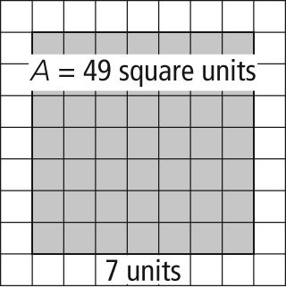
4. a) (5)(5)(5) b) 5³
5. a) (–3)⁷ b) 2⁸ c) 7⁷ d) 2¹² = 8⁴ e) –6
6. a) 512 b) 2592 c) 1 d)
7. a) 88.2 m b) 80 km/h
8. 268 cm³

