Chapter 5 Prerequisite Skills Answers

BLM 5–2 Chapter 5 Prerequisite Skills
1. a) 1 term, monomial b) 1 term, monomial
c) 3 terms, trinomial d) 3 terms, trinomial
2. a) 3x – 3 b) x² + 4x c) –3x² – x + 4
3. a) –9x² b) 6t² c)
4. a) 5p b) –4n c) –4.2y
5. Since x = 50, the dimensions of the rectangle are 250 cm by 50 cm.
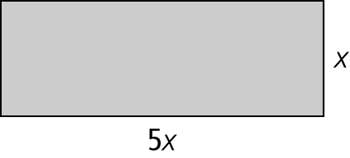
6.
7. a) 6x² – 2x b) 20k² – 5k
c) 4x² – 12x d) 1.2p² – 0.4p
8. a) 5b – 4 b) –3m² + m c) –4h + 1
9. 3x² + 6x 10. 5v – 4

