Chapter 6 Prerequisite Skills Answers

BLM 6–2 Chapter 6 Prerequisite Skills
1. a) 0.50, 50% b) 0.60, 60%
c), d) 3, 300%
2. a) 108 km/h b) 160 m/km c) 50 m/min
3. 1.99 m
4. a)
Time Worked, t (h) | Earnings, E ($)
2 | 30
4 | 60
6 | 90
7 | 105
b) (0, 0). Example: This means that for 0 time worked, the earnings are $0.
5. a) 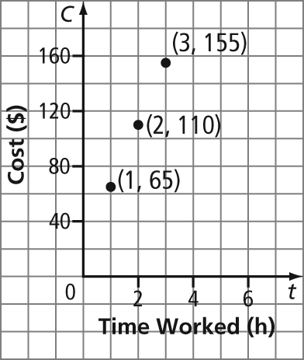
b) $290 c) C = 45L + 20
6. a) y = 8.04 b) t = –14.56
c) r = d) n = 15
7. a) $50.25 b) 48 hotdogs

