Chapter 8 Prerequisite Skills Answers

BLM 8–2 Chapter 8 Prerequisite Skills
1. a) Example:
w | L
0 | 12
1 | 16
2 | 20
3 | 24
4 | 28
5 | 32
b) Example: Yes. The values of both the domain and range belong to the real numbers.
c) Example: 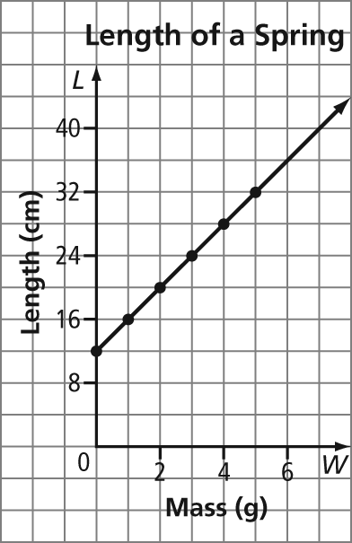
d) 22 cm e) 3.25 g
2. a) 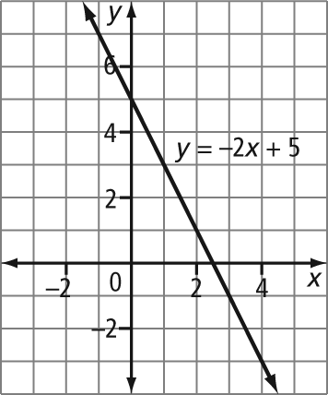
b) 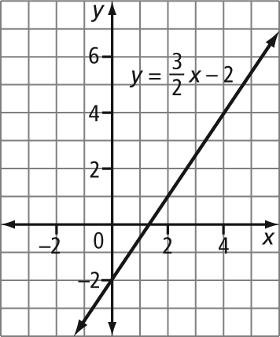
c) 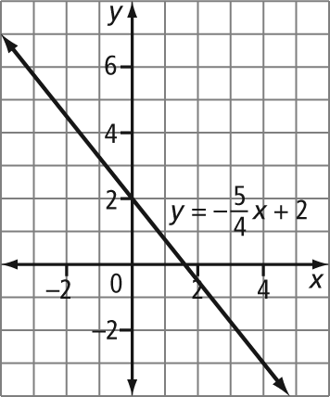
3. a) T b) (3, 0) c) P and R d) Several combinations are possible. Examples: PRT, QST, QSU, RST, RSU
e) 4 units
4. a) (3, 7). Example: The slope must be constant for these points to represent a linear relation. The slope between the first two points, (1, 1) and (2, 4), is 3. So, the top point should be up 3 and to the right 1. The point must be located at (3, 7).
b) (1, –1)
5. Example: 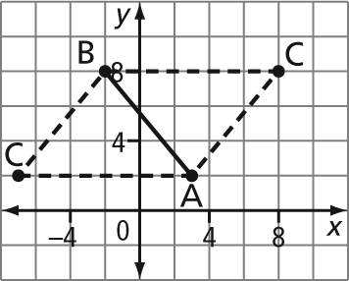
(–7, 2) and (8, 8)
6. a) Example: The pattern starts with one circle. To create each subsequent diagram, a row of three circles is added.
b)
Diagram Number | Number of Circles
1 | 1
2 | 4
3 | 7
4 | 10
c) 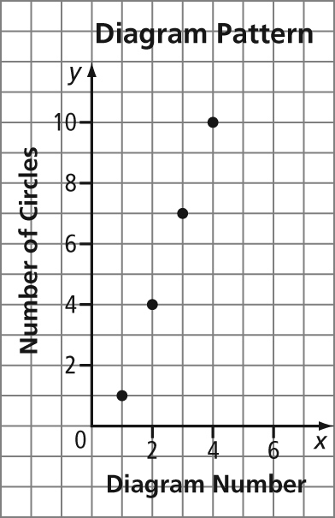
7. Example: 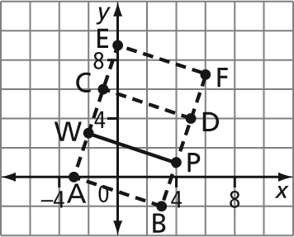
Rectangles ABPW, PWCD, and PWEF
8. a) Example: 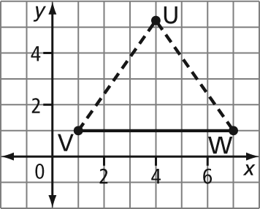
b) Example: The x-coordinate of point U is 4. If U is in quadrant I, the y-coordinate is positive and has a value between 6 and 7. If U is in quadrant IV, the
y-coordinate is negative.

