Chapter 9 Prerequisite Skills Answers

BLM 9–2 Chapter 9 Prerequisite Skills
1. a) y = 2x + 5 b) y = x – c) y = 4x + 3
2. Example: 2c + 10. Let c represent Carole’s age.
3. a) 9 b) Let n represent the term number. 2n – 1
4. a)
Term Number | 1 | 2 | 3
Number of Squares | 3 | 5 | 7
b) Example: Continue the pattern in the chart, drawing the additional diagrams needed, or develop a formula to represent the pattern and use the formula to calculate the number of squares. c) 2t + 1
5. a) t – 5 b) Example: Let the original number of almonds in the bowl be n. n + 12 c) Example: Let your age be x. Your brother’s age is x + 10.
6.
Term Number | 1 | 2 | 3 | 8
Number of Squares | 8 | 12 | 16 | 36
7. a) 4x – 3
b) 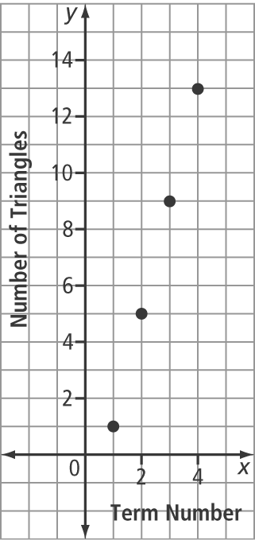
8. a) 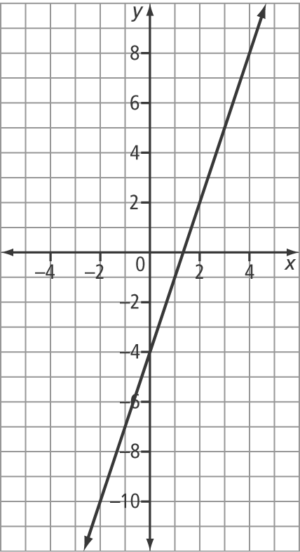
b) Example: No, the graph would not change, because the relationship between the variables has not changed. c) Example: No
d) No e) Example: When you multiply or divide both sides of an equation by the same value (other than zero), the line does not change.
9. a) c = 40 cm b) c = 27.5 cm c) Yes. Example: Substitute 600 for m to get c = 20. This means that the ground clearance is 20 cm. Because the curb is only 18 cm high, the bumper will clear it. d) 1000 kg

