How to Do Page 79 #18 Using
Microsoft® Excel

1. Open Microsoft® Excel spreadsheet software on your computer.

2. Save your file before you begin.
- Click on File, then Save As.
- Save the file using a filename of your choice.
- Click OK.

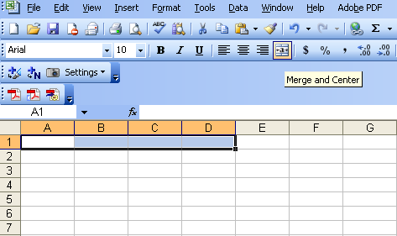
3. Give your spreadsheet a title. Do the following:
- Click and drag to highlight the first 4 cells in Row 1 (from Columns A to D). See Figure 1.
- Click the Merge and Center button .
- Enter a title such as “Investigating Changes in
Dimensions of a Sphere”.
- To make enough room for the title, you may have to click and drag the columns to expand them.
Figure 1
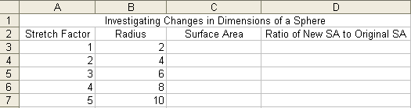
4. Give each column a title. See Figure 2.
- Click the first cell in Row 2 (Column A), and enter the title “Stretch Factor”.
- Repeat the procedure to enter the following titles:
Figure 2
– “Radius” for Column B,
– “Surface Area” for Column C, and
– “Ratio of New SA to Original SA” in Column D.
- You may have to click and drag the columns to expand them.
- Centre the titles.

5. Enter the following information in the Stretch Factor column: 1, 2, 3, 4, 5. See Figure 2.

6. Enter the following information in the Radius column: 2, 4, 6, 8, 10. See Figure 2.
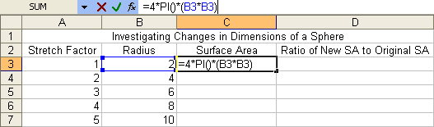
7. Highlight the first cell in the Surface Area column.
- Enter the formula for surface area: =4*PI()*(B3*B3), where B3 is the first entry in the Radius column. See Figure 3.
Figure 3
- Press Enter.

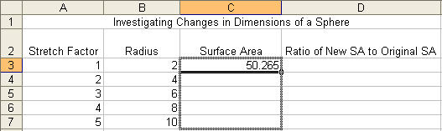
8. To continue entering the surface area formula, do the following:
- Click to highlight the first cell in the Surface Area column.
- Click on and hold the small black square that
appears in the lower right corner of the cell.
Figure 4
- Drag down to the last cell in the column (Row 7) and release. See Figure 4, which was taken just before the release.
- The formula will fill in those cells.

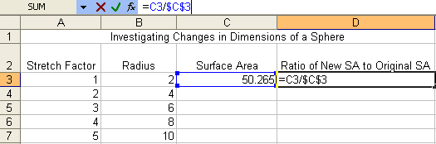
9. To calculate the ratio of the new surface area to the original surface area, do the following:
- Highlight the first cell in the Ratio of New SA to Original SA column.
- Enter the formula for the Ratio of
Surface Areas: =C3/$C$3. See Figure 5.
Figure 5
- Press Enter.

10. To continue entering the ratio formula, follow the same steps you did in Step 8.
- Click to highlight the first cell in the Ratio of New SA to Original SA column.
- Click on and hold the small black square that appears in the lower right corner of the cell.
- Drag down to the last cell in the column (Row 7) and release.
- The formula will fill in those cells.
11. Save your spreadsheet.

12. Compare the stretch factor for the radius to the ratio of the new surface area to the original surface area. What pattern do you notice?

13. Use your pattern from #12 to predict the surface area of the sphere if you multiply the radius by 6.

14. Extend your spreadsheet to check your prediction in #13.
- Highlight all the data in the cells of the Stretch Factor column.
- Click on and hold the small black square that appears in the lower right corner of the last filled cell.
- Drag down until the desired number of new rows of cells are filled. For example, drag down one row for a stretch factor of 6, further for larger values.

15. Highlight cells and drag the small black box as explained above for the remaining three columns.
- Ensure that new column entries match up. Extending a column past an adjacent column or not extending a column far enough may result in an error message.

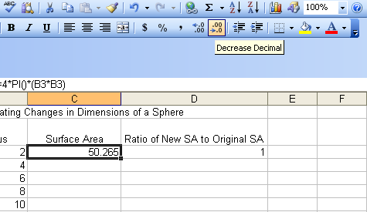
16. To reduce the number of decimal places visible in the Surface Area column, highlight the data cells and press the Decrease Decimal button . See Figure 6.
Figure 6

