How to Do Page 300 Example 4 Using
TI-83/84
Use the TI-83/84 to graph the formula h = 4.5a + 25 for domain [14, 42] and range [88, 214].
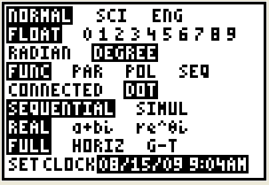
1. Place the calculator in Dot Mode. This will eliminate the vertical lines at the start and end of the domain.
• Press .
• Cursor over DOT.
• Press . You will see Figure 1.
Figure 1

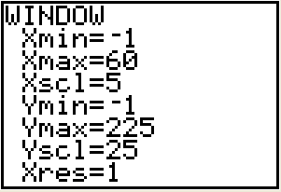
2. Set the window variables.
• Press .
• Use the given domain and range values to set an appropriate window setting. You will see Figure 2.

3. Enter the equation of the relation and the domain in the
form (equation)(domain).
Figure 2
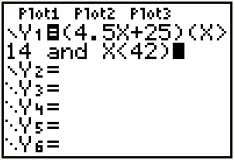
• Press 
• Clear any previous plots.
• Enter the equation in brackets: (4.5x + 25).
• Enter the domain.
– Press     and select 3: >.
Then, enter 14.
Figure 3
– Press and cursor over to LOGIC.
Select 1: and.
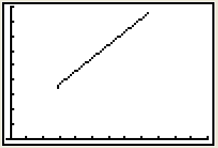
- Press and select 5: <.
Then, enter 42 and press .
– Press . You will see Figure 3.

4. Display the graph.
• Press . You will see Figure 4.
Figure 4
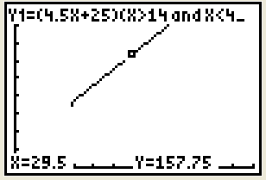
• Press  to display values on the graph. You will see Figure 5.
• Use the left and right arrows to move the trace point along the graph.

Figure 5

