How to Do Page 300 Example 4 Using Microsoft® Excel

1. Open the Microsoft® Excel spreadsheet software on your computer.

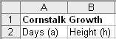
2. Give your spreadsheet a title and enter column headings. Do the following:
• Highlight cells A1 and B1. From the menu at the top of the page, select Format → Cells → Alignment → Merge cells.
Figure 1
• Enter a title, such as “Cornstalk Growth”.
• In cell A2, enter the heading “Days (a)”.
• In cell B2, enter the heading “Height (h)”.
See Figure 1.

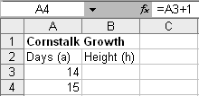
3. In column A, display the number of days in the domain
[14, 42].
Figure 2
• In cell A3, enter “14”.
• In cell A4, enter the formula “=A3+1”. See Figure 2.
• To copy this formula, click and hold down on cell A4 and then drag the cursor so cells A4 to A31 are highlighted. Then, hold down the Ctrl key while typing d. (This is equivalent to choosing Edit → Fill → Down.)

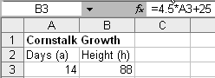
4. In column B, generate the heights of the cornstalks based
on the number of days.
Figure 3
• In cell B3, enter the formula “=4.5*A3+25”. See
Figure 3.
• To copy this formula, click and hold down on cell B3 and then drag the cursor so cells B3 to B31 are highlighted. Then, hold down the Ctrl key while
typing d. See Figure 4.
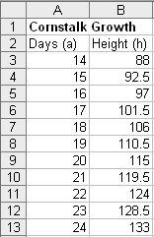
Figure 4

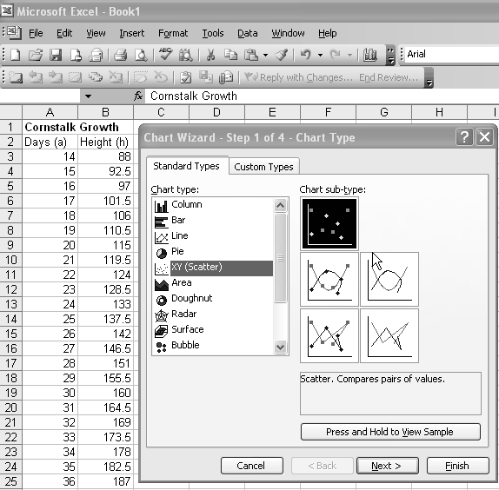
5. Display the graph.
Figure 5
• Highlight cells from A1 and B1 to A31 and B31.
• From the menu at the top of the page, select Insert → Chart → Scatter. See Figure 5.

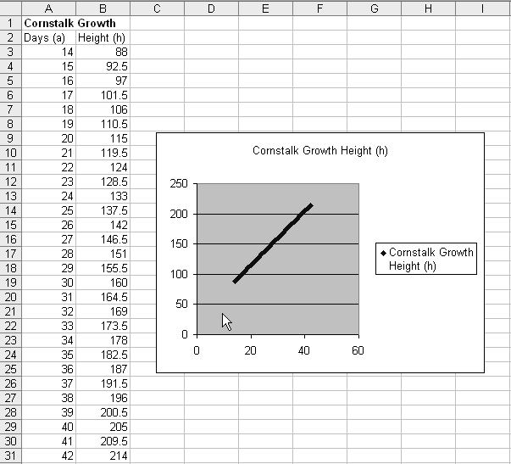
• The graph will be displayed as in Figure 6. Various aspects of the graph may be formatted with a right-click on the desired section.

Figure 6

