How to Do Page 343 Example 1 Using Microsoft® Excel
1. Open the Microsoft® Excel spreadsheet software on your computer.

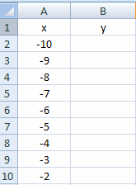
2. Enter the column headings for the table of values, as shown in
Figure 1.
• In cell A1, enter “x”.
• In cell B1, enter “y”.

3. Enter the values for x. See Figure 1.
• Type a starting number, say –10, in cell A2.
• In cell A3, enter the formula =A2+1 and press Enter.
• To copy this formula, click (and hold down) on cell A3 and then drag the cursor so cells A3 to A20 are highlighted. Then, hold down the Ctrl key while typing d. (This is equivalent to choosing Edit → Fill → Down.)
Figure 1

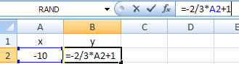
4. Calculate the y-values.
• In cell B2, enter the equation of the line
= –2/3*A2+1 and press Enter. See Figure 2.

Figure 2
• To copy this formula, click (and hold down) on cell B2 and then drag the cursor so cells B2 to B20 are highlighted. Then, hold down the Ctrl key while typing d. You will see Figure 3.
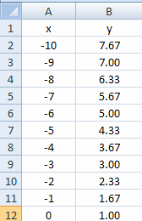

Figure 3

5. Display the graph.
• From the menu at the top of the page, select Insert → Chart → Scatter. See Figure 4.

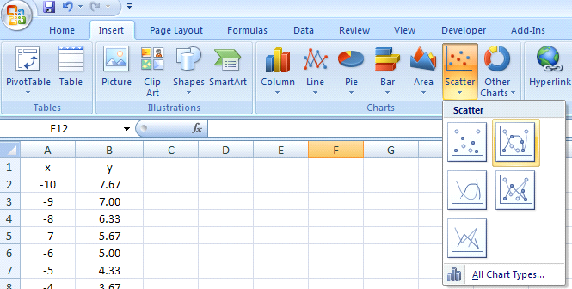

Figure 4

• The graph will be displayed as in Figure 5. Various aspects of the graph may be formatted with a right-click on the desired section.

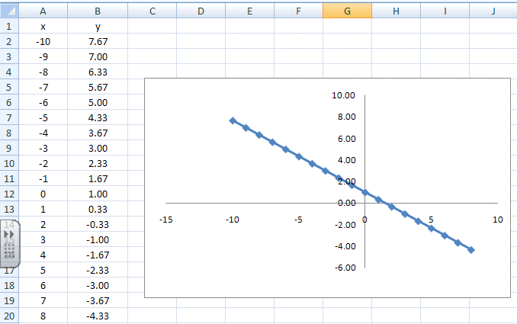
Figure 5

