How to Do Page 420 Example 2 Using Microsoft® Excel

1. Open the Microsoft® Excel spreadsheet software on your computer.

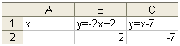
Figure 1
2. Enter the column headings for the table of values, as shown in Figure 1.
• In cell A1, enter “x”.
• In cell B1, enter “y = –2x + 2”.
• In cell C1, enter “y = x – 7”.

3. Enter the equations for the y-values.
• In cell B2, enter the formula “= –2*A2+2” and press Enter.
• In cell C2, enter the formula “= A2–7” and press Enter.
See Figure 1.

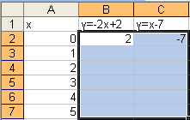
4. Complete the table of values.
• In column A, enter the values for x.
• To copy the formulas, click (and hold down) on cell B2 and then drag the cursor so cells B2 and C2 and down to B7 and C7 are highlighted. See Figure 2.

Figure 2

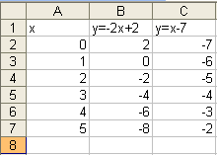
• Then, hold down the Ctrl key while typing d. (This is equivalent to choosing Edit → Fill → Down.) You will see Figure 3.
Figure 3

