Chapter 3 Warm-Up
Section 3.1 Warm-Up

1. Calculate each to one decimal place.
a)
b)
c)
2. How large is the unknown acute angle in each triangle?
a) 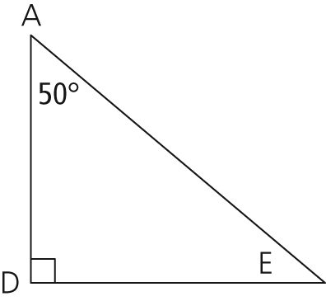
b) 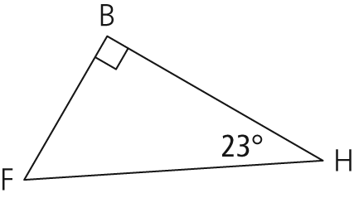
c) 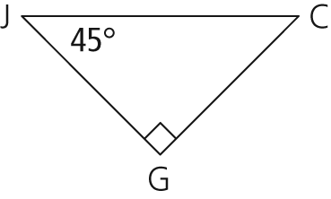
3. For each triangle, identify the hypotenuse.
a) 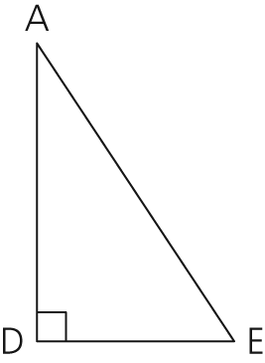
b) 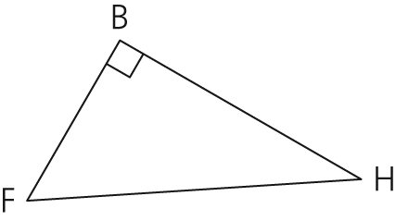
c) 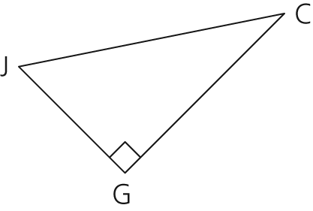
4. If these two polygons are similar, which proportion would you solve to find x?
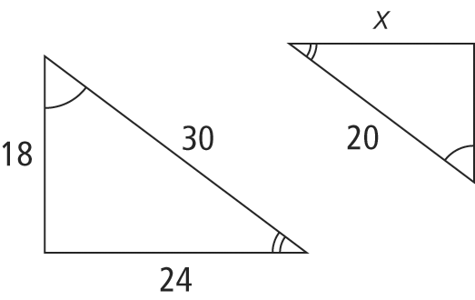
A
B
C
D
5. If quadrilateral ABCD is similar to quadrilateral EFGH, find each of the following:
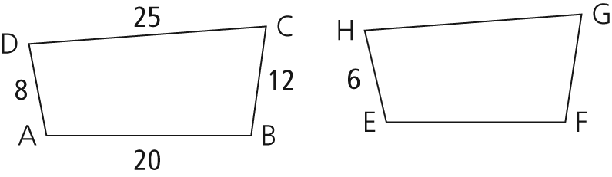
a) EF
b) FG
c) GH

Section 3.2 Warm-Up

1. Calculate each to three decimal places.
a) tan 43°
b) tan 72°
c) tan 60°
2. Calculate each angle. Express your answer to the nearest degree.
a) tan A = 0.258
b) tan A = 2.580
c) tan A =
3. Calculate x for each equation. Express your answer to one decimal place.
a) tan 43° =
b) tan 43° =
c) tan 60° =
d) tan 60° =
4. Which side is adjacent to the marked angle in each triangle?
a) 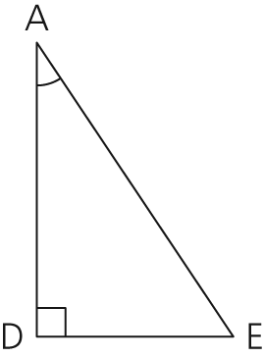b) 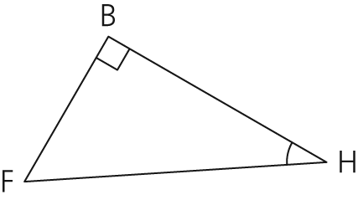

c) 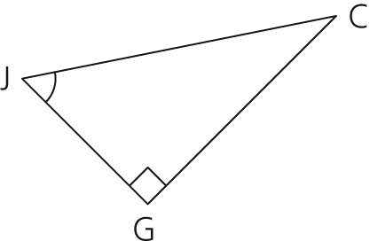
5. Find the missing length, y, to one decimal place.
a) 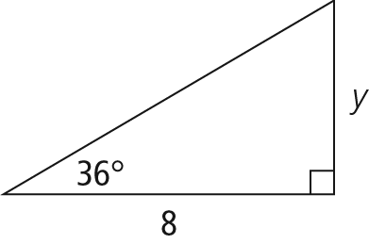
b) 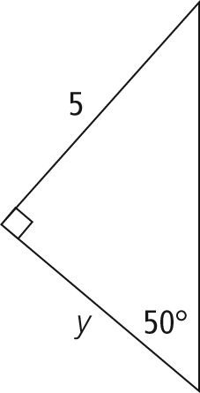

Section 3.3 Warm-Up

1. Calculate each to three decimal places.
a) sin 43°
b) cos 43°
c) tan 43°
2. Calculate each angle to the nearest degree.
a) sin A
b) cos A
c) tan A
3. Calculate x for each equation. Express your answer to one decimal place.
a) sin 43° =
b) cos 18° =
4. Which side is opposite to the marked angle in each triangle?
a) 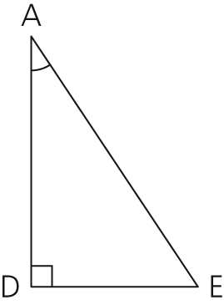
b) 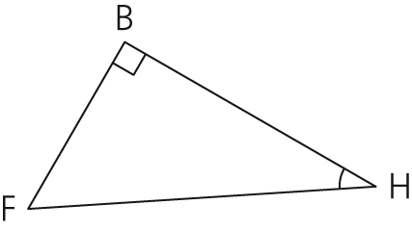
c) 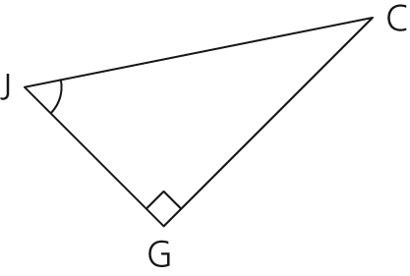
5. Find x. Express the size of angles to the nearest degree, and lengths to one decimal place.
a) 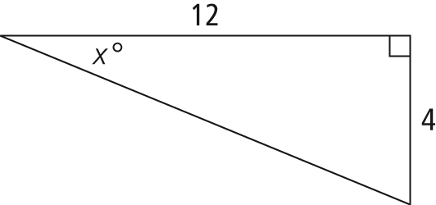
b) 