Chapter 2 Gifted and Enrichment
1. A right cylindrical bird feeder has a radius of 4.5 cm and a height of 29 cm. Three circles, each with a diameter of 4.5 cm, have been cut from the curved surface of the cylinder in order for birds to feed. Determine the surface area of the feeder to be painted, to the nearest square centimetre. Assume that the cut outs are not painted.  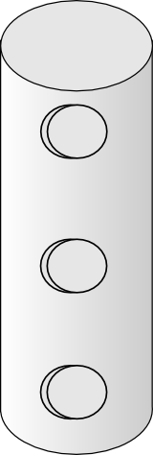  29 cm  4.5 cm  4.5 cm | 2. An observatory is composed of a right cylinder and a hemispherical dome. What is the volume of air in the observatory, to the nearest thousand cubic yards?  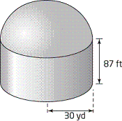
3. Lia is making wooden boxes that she sells online.
a) The smallest box that she makes measures 6 cm by 11 cm by 11 cm. Determine the volume of the box in cubic centimetres.

b) What is the volume of the box in part a) in cubic inches, to the nearest cubic inch?

c) Lia wants to build a larger box that has a square base and the same height of 11 cm, but twice the volume of the small box. Determine the dimensions of the new box, in SI and imperial units. Express each answer to the nearest tenth of a unit.

d) When Lia began to design the new box, she made a prototype in which each side was twice as long as the corresponding side of the small box. Explain why this prototype did not have the desired volume.
4. Ashton wants to plant tomatoes in a raised bed. The depth of the compost mix in the bed needs to be 8 in.. If compost mix is sold in 4 ft³-bags, how many bags should he purchase?
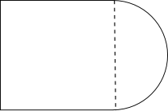
2 m
2 m

5. Explain the effects of each change on the volume of a right cone with radius r and height h.
a) The radius is doubled.

b) Both the radius and height are doubled.

c) The radius is doubled and the height is halved.

6. Which of the following objects has the greatest surface area? Justify your answer mathematically.
a) A right prism is 2 m long, 2 m wide, and 4 m tall.

b) A cube has edge lengths of 4 m.

c) A right pyramid with a 3-m by 3-m base has a slant height of 5 m.

