Chapter 5 Gifted and Enrichment
1. What is the simplified form of the product  (6x² + 2x + 6)²? | 2. Factor 3x³ + 9x² – 3x – 9.
3. Brian wants to install a concrete patio in his backyard. The patio measures 4 m by 5 m. A diagram of his backyard is shown.
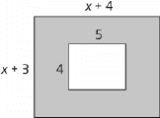

a) Write an algebraic expression, in factored form, to represent the shaded area of the diagram. This represents the portion of Brian’s backyard that is not covered by the patio.

b) Brian needs an area of 20 m² in the yard not covered by the patio for a dog run. When Brian measures his backyard, he determines that x = 3. Is Brian’s backyard large enough for the patio and the dog run? Use mathematics to justify your answer.
4. Rachel is creating a page in her scrapbook. She places a square photo on a square sheet of scrapbook paper, as shown.

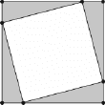

The difference between the area of the photo and the sheet of scrapbook paper is 17 cm². The sum of the perimeters of the photo and the sheet of scrapbook paper is 68 cm. How long are the sides of the sheet of scrapbook paper?
5. Determine all of the positive values of k for which x² + 12x + k is factorable over the integers.
6. The first three figures in a pattern are shown.

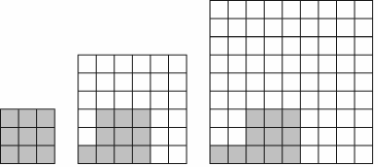
Figure 1 Figure 2 Figure 3

a) Write an expression for the total number of small squares in Figure n.

b) Write an expression for the number of small squares that are shaded in Figure n.

c) Write an expression for the number of small squares that are unshaded in Figure n.

d) Write the expression from part c) in factored form.

e) Show mathematically that your answers in part c) and part d) result in the same number of
unshaded small squares for Figure 20.

