Chapter 6 Gifted and Enrichment
1. Angela rents shoes at the bowling alley for $3.00. It costs $2.50 to bowl each game.  a) Develop an equation that represents the cost of bowling. Use the form C(x) = mx + b, where C(x) is the total cost, and x is the number of games bowled. Show your thinking.  b) Is the relation in part a) a function? Explain.  c) How much does it cost Angela to bowl four  games? | 2. Jaime enjoys rock climbing. Recently, she climbed down a 2500-ft cliff at a rate of 20 ft/min.  a) Write an equation, in function notation, to represent Jaime’s height, h, in feet, above the ground after t min.  b) Create a table of values for Jaime’s height above the ground for values of t from 0 min to 4 min.  c) What was Jaime’s height above the ground after  40 min?  d) How many minutes did it take Jaime to reach the ground?  e) What are the domain and range for this relation?
3. Robert is buying jerseys for his school hockey team. Each jersey costs $50 plus 14% in taxes. He also needs to buy a storage box for the jerseys that costs $100 plus 14% in taxes. He has a budget of $798.

a) Write a function to represent the amount, B(j), of money that remains in the budget after buying the storage box and j jerseys.

b) Make a table of values for the amount of money that remains after buying 0 to 4 jerseys.

c) How much money remains in the budget after Robert buys 8 jerseys?

d) What is the maximum number of jerseys that Robert can buy and stay within the budget?
4. Clark earns $40 for every fence he paints. The cost of paint for one fence is $16. He spent a total of $6 on paint brushes before he started painting and is using a recycled paint tray. His profit is equal to his earnings minus all of his expenses.

a) Write a function that represents Clark’s total profit for any number of fences painted. Let P represent profit, in dollars, and let f represent the number of fences painted.

b) Make a table of values for 0 to 5 fences painted.

c) How much profit will Clark earn if he paints 15 fences?

d) How many fences would Clark have to paint in order to earn a profit of $474?
5. Use the graph to answer parts a) to f).

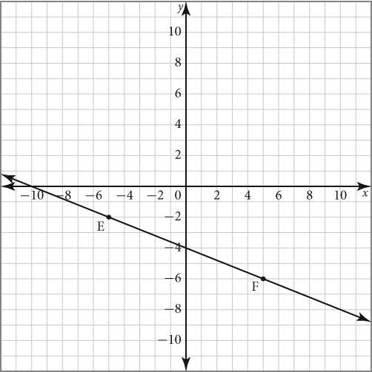

a) State the coordinates of points E and F.

b) Determine the rise between points E and F.

c) Determine the run between points E and F.

d) Determine the slope of the line containing points E and F.

e) State the y-intercept of the line containing points E and F.

f) State the equation of the line containing points E and F.
6. John and Stella are raising money for charity by selling raffle tickets for $2 each. The winner will receive a bicycle that was donated for the raffle. The students spent $50 to print the tickets. The amount of money raised for charity is equal to the value of the tickets sold minus the cost of printing the tickets. The table of values represents this situation.

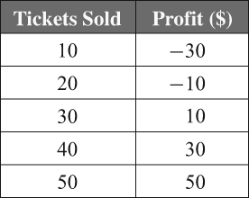

a) Is this a linear or non-linear relation? Explain.
b) Are the data discrete or continuous? Explain.
c) What are the domain and range of this relation?
d) How many tickets must be sold to break even?

