Chapter 6 Gifted and Enrichment Answers

1. a) In C(x) = mx + b, the fixed cost is $3.00, so b = 3.
The slope is the rate per game, so m = 2.5.
C(x) = 2.5x + 3.
b) Yes, this is a function because for every value of x there is only one corresponding value for C(x).
c) C(4) = 2.5(4) + 3
C(4) = 13
The cost to bowl four games is $13.
2. a) Jaime started at 2500 ft above ground and travelled 20 ft/min. The equation h(t) = 2500 – 20t represents Jaime’s height, in feet, above ground t min after she started climbing.
b)
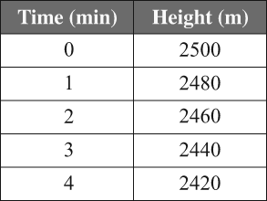
c) Substitute t = 40 into the equation.
h(t) = 2500 – 20t
h(40) = 2500 – 20(40)
h(40) = 2500 – 800
h(40) = 1700
Jaime was 1700 ft above ground after 40 min.
d) Substitute h(t) = 0 into the equation.
h(t) = 2500 – 20t
0 = 2500 – 20t
20t = 2500
t = 125
It took Jaime 125 min to reach the ground.
e) Domain: {0, 125}; Range: {2500, 0}
3. a) Cost of jersey = 50 + 0.14(50)
= 57
One jersey costs $57. Represent the cost of j
jerseys by 57j.
Cost of box = 100 + 0.14(100)
= 114
The storage box costs $114.
Represent the amount of money that remains in the
budget by the function B(j) = 798 – 114 – 57j.
B(j) = 684 – 57j
b)
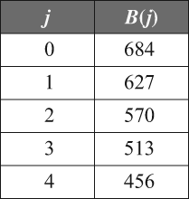

c) Substitute j = 8 into the equation.
B(j) = 684 – 57j.
B(8) = 684 – 57(8)
B(8) = 228
After Robert buys 8 jerseys, $228 will remain in
the budget.
d) Substitute B(j) = 0 into the equation.
B(j) = 684 – 57j
0 = 684 – 57j
j = 12
Robert can buy a maximum of 12 jerseys.
4. a) Subtract the cost of paint (16f) and the starting
expenses from 40f to calculate the profit.
P(f) = 40f – 16f – 6
P(f) = 24f – 6
b)
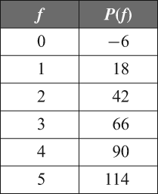
c) Substitute f = 15 into the equation.
P(f) = 24f – 6
P(15) = 24(15) – 6
P(15) = 354
Clark will earn $354 if he paints 15 fences.
d) Substitute P(f) = 474 into the equation.
P(f) = 24f – 6.
474 = 24f – 6
20 = f
Clark would need to paint 20 fences to earn $474.
5. a) E(–5, –2); F(5, –6)
b) rise = –6 – (–2)
= –4
The rise is –4.
c) run = 5 – (–5)
= 10
The run is 10.
d)
The slope is .
e) On the graph, the line with E and F crosses the y-axis at –4, so the y-intercept is –4.
f) y = mx + b
The equation of the line is
6. a) This is a linear relation as the data points form a
straight line. With each increase of 1 in the number
of tickets sold, the profit increases by $2.
b) The data points are discrete, as there are no partial raffle tickets.
c) Domain: {t| t ≥ 0, t ∈ N}; Range: all even integers greater than or equal to –50
d) When profit = 0, the raffle will break even. The number of tickets that must be sold for the raffle to break even is 25.

