Chapter 7 Gifted and Enrichment Answers

1. Substitute y = 2a and x = a into 3x – 4y + 20 = 0:
The point is (4, 8).
Check that (4, 8) is on the line:
Left Side Right Side
3x – 4y + 20 0
= 3(4) – 4(8) + 20
= 12 – 32 + 20
= 0
Left Side = Right Side
The point (4, 8) is on the line.
2.
Since the slopes of AB and CD are equal, AB and CD
are parallel. Since the slopes of BC and DA are equal,
BC and DA are parallel. So, quadrilateral ABCD is a
parallelogram. In addition, AB is perpendicular to
DA because the product of their slopes is
. Because the adjacent sides are
perpendicular, ABCD is a rectangle.
3. Line 1:

Line 2:
Line 3:
Graph each line:
The vertices of the triangle are (–3, 8), (0, –7), and
(6, 2).
4. a)
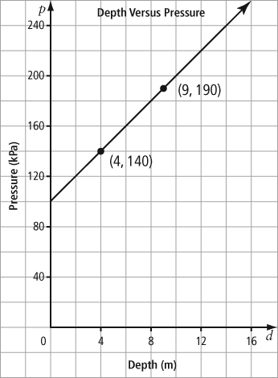

b) From the graph, the slope is 10 and the p-intercept is 100. The equation of the line is p = 10d + 100.
c) The slope is 10, which means that the increase in pressure for each metre that the diver descends is 10 kPa. The p-intercept is 100, which means that the pressure at the surface is 100 kPa.
d) The pressure at the surface is 100 kPa, so determine the depth that corresponds to 200 kPa on the graph. The pressure is 200 kPa at a depth of 10 m. At a depth of 10 m, the pressure is double the pressure at surface.
5. a) Let E represent Sarah’s earnings per day and p
represent the number of purses she sells. Her
commission is 10% of $80, or $8. The equation is
E = 8p + 60.
b) Substitute p = 10 into the equation E = 8p + 60:
E = 8(10) + 60
E = 140
Sarah will earn $140 if she sells 10 purses in a day.
c) Substitute E = 220 into the equation E = 8p + 60:
Sarah needs to sell 20 purses to earn $220 in a day.

