Chapter 2 Warm-Up Answers

BLM 2–3 Chapter 2 Warm-Up
Section 2.1
1. a) For Ed’s project, using large units, such as kilometres results in very small numbers. It would be more appropriate to measure in metres and centimetres. b) 23.8 m; 17.9 m
2. a) Use inches or feet, as they are smaller units than yards but large enough that most measurements can be expressed as whole numbers.
b) Students may convert all measurements to inches or feet.

13 in. | 3.75 ft | yd
13 in. | 45 in. (3 ft = 36 in.) + (0.75 ft = 9 in.) | 12 in.  (1 yd = 36 in.)
1 ft 1 in.  (12 in. = 1 ft) | 3.75 ft | 1 ft  (1 yd = 3 ft)
3. Example:
- Convert 180.3 cm by 101.6 cm to approximately
71 in. by 40 in. or 5.9 ft by 3.3 ft.
- Estimate the area to be about 6 ft by 3 ft or 18 ft².
- Estimate the cost to be at least (18)(75) = $1350.
4. Area is the number of square units needed to cover a surface. For example, 47 m² means 47 squares each with side length 1 m and area 1 m².
5. Volume is the amount of space that an object occupies.
Section 2.2
1. a) 90 000 cm². 1 m = 100 cm
b) 144 in.². 1 ft = 12 in.
2. 176 in.²
3. a)
Dimensions | 1 by 17 | 2 by 16 | 3 by 15 | 4 by 14 | 5 by 13 | 6 by 12 | 7 by 11 | 8 by 10 | 9 by 9
Area (m²) | 17 | 32 | 45 | 56 | 65 | 72 | 77 | 80 | 81
b) 9 m by 9 m gives the largest area.
4. The diameter of the circle is the length of one square multiplied by 7, as the squares and the line segments that connect them are equal in length. Half of the diameter is the radius. Substitute the value of the radius in the formula SA = πr² to solve the area of the circle. Then, subtract the area of the squares (or 3 times the area of one square) to find the area of the shaded portion.

5. a) 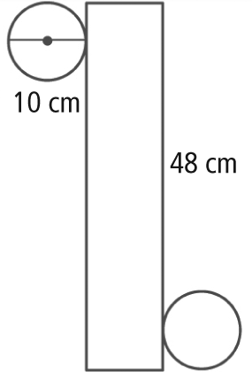
b) 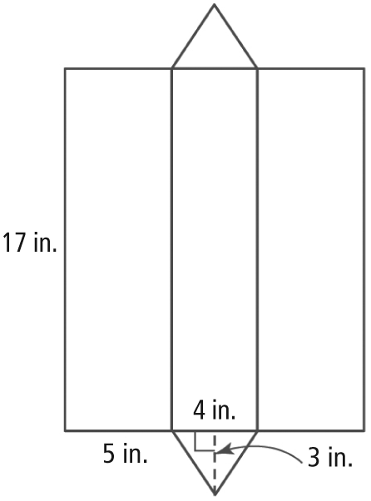
Section 2.3
1. Volume is the number of cubes that fill the space that an object occupies. For example, 4m³ is made up of four 1-m³ cubes. Each cube is 1 m in length by 1 m in width by 1 m in depth.
2. 1 m = 100 cm, 1 000 000 cm³
3. Using the Pythagoras relationship, c² = a² + b² ; 8² = 4² + h² ; height = 6.9 cm
4. 6 cm
5. Add the sum of the volumes of the square-based pyramid and the three prisms.

