Chapter 6 Warm-Up Answers

BLM 6–3 Chapter 6 Warm-Up
Section 6.1
1. a)
Time, t (s) | Distance Walked, d (ft)
30 | 50
60 | 100
90 | 150
120 | 200

b) 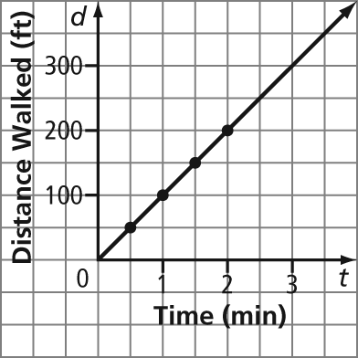
2. a)
Time, t (s) | Distance Walked, d (ft)
30 | 75
60 | 150
90 | 225
120 | 300
b) 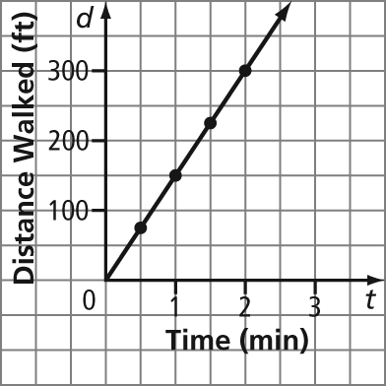
3. Example: The scenario with the faster speed creates a steeper line than the scenario with the slower speed.
4. a)
Time t, (min) | Distance From School d, (km)
0 | 5
2 | 5
4 | 5
6 | 5
b) 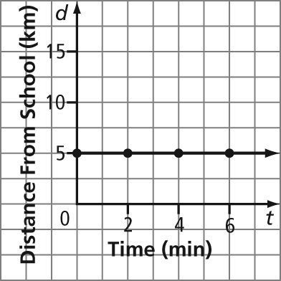
5. a) 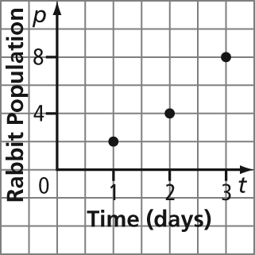
b) Example: No. The data does not lie in a line.
Section 6.2
1. a) 1 b) 2 c) 3 d) 0 2. A
3. Example: number of stock of various shoe sizes over time
4. Example: distance travelled by a vehicle moving at a constant speed over time
5. Example: distance travelled by a soccer ball after it is kicked into the air over time
Section 6.3
1. all real numbers greater than and including 3
2.
3. all real numbers greater than or equal to –2 and less than or equal to 3
4.
5. Examples:
a) multiples of 1; start at 0; end at 5
b) multiples of 100; start at 0; end at 300
Section 6.4
1. a) 1, 2, 9 b) –3, –1, 0 c) all real numbers
2. a) 3, 4, 5 b) 1, 4, 7 c) all real numbers
3. a) y = 32 b) y = 14
4. a) x = 5 b) x = –7
5. 65 min
Section 6.5
1. a) 2 b) 3 2. a) 9 b) 4
3. a)
b) 
c) 
4. a) Example: 0. There is no rise or steepness.
b) Example: undefined or no number. There is no run. Division by zero is not defined.
5. Examples:
a) (3, 7) b) To go from (0, 4) to (2, 5), you move two right and one up. So, the next point that is two right and one up is (3, 7).

