Chapter 7 Warm-Up Answers

BLM 7–3 Chapter 7 Warm-Up
Section 7.1
1. a) b) c) undefined
2. a) b) 2
3. a) x-intercept: (9, 0), y-intercept: (0, 6)
b) x-intercept: (1, 0), y-intercept: (0, –2)
4. a) $240 b) $400
c) Example: Let C represent the cost, in dollars. Let t represent time, in hours. C = 200 + 4t
5. a) or b) d =
Section 7.2
1. a) y = x + 6 b) y = 2x – 2
2. a) y = –4 b) x = 5
3. a) 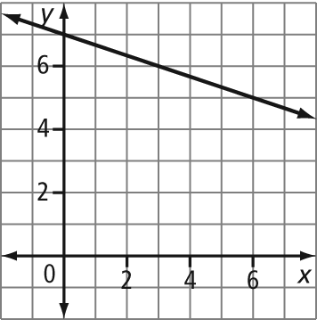
y = x + 7
b) 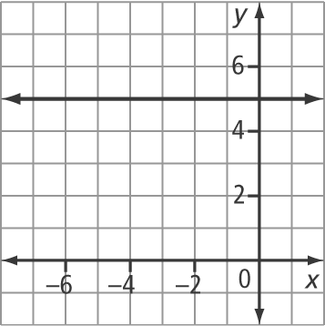
y = 5
4. a) x = b) x = –28
5. a) y = x + 3 b) y = x + 4
Section 7.3
1. a) 2x – 3y + 3 = 0 b) x + 5y + 15 = 0
2. a) 2x – y + 13 = 0 b) 4x – y – 6 = 0
3. a) 3x – 12 b) 4x – 4
4. a) y = x – 5 b) y = x + 2
5. a) 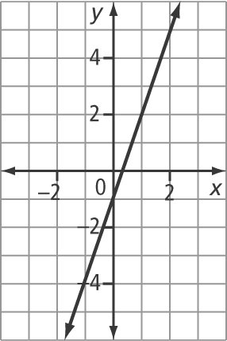
y = 3x – 1
b) 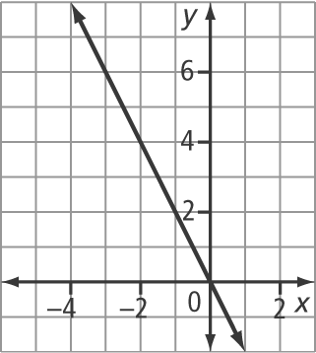
y = –2x
Section 7.4
1. a) 3 b)
2. a) y – 5 = (x + 1) b) y – 2 = (x – 4) or
y – 3 = (x – 8)
3. a) y = –4x + 15 b) y = x + 6
4. 4x + y – 19 = 0
5. a) b) c) 5

