Chapter 8 Warm-Up Answers

BLM 8–3 Chapter 8 Warm-Up
Section 8.1
1. B
2. (–4, 3); 2x + y = 5
Left Side Right Side
2x + y 5
= 2(–4) + 3
= –8 + 3
= –5
Left Side ≠ Right Side
3. 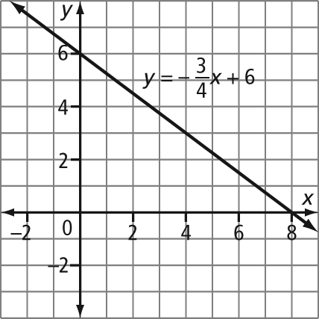
4. y = x – 6; slope, y-intercept –6
5. 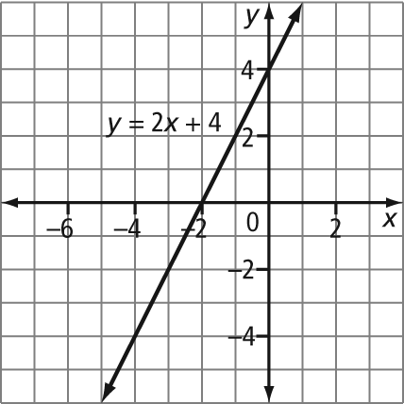
Section 8.2
1. 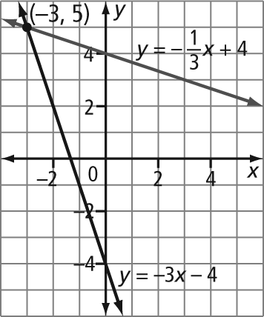
2. 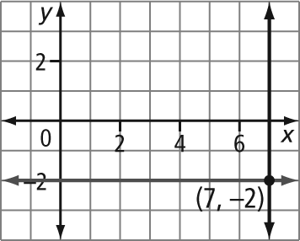
3. a) 2x + 3 b) x – 7 c) 3x –x or 3x – 0.5x
4. a) 12 ft/min b) 3 c) $0.07/min
5. a) 0 km b) $0 c) $500

Section 8.3
1. a) 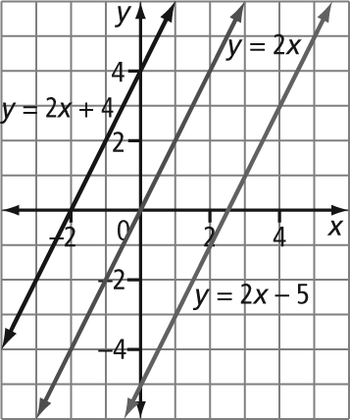
b) They all have the same slope.
c) No
2. a) 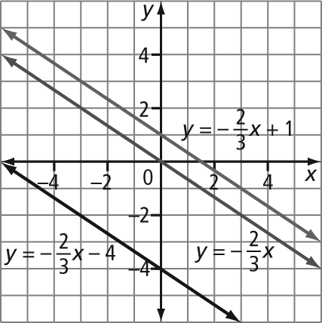
b) Example: These lines are parallel, because they all have the same slope.
c) Example: y = 2x + 1
3. a) 1, 2, 3, 4 b) –2, –1, 0, 1
c) –6, –5, –4, –3, –2
4. Example: 0.1, 0.2, 0.4, 0.7, 0.95
5. Example: There are an infinite number of real numbers between 0 and 1.

