Chapter 9 Warm-Up Answers

BLM 9–3 Chapter 9 Warm-Up
Section 9.1
1. the number of students who attended and the number of adults who attended
2. the cost to take a car on the ferry and the cost for an adult to ride the ferry
3. a) y = – 4 b) y = –– 10
4. a) x = 1 b) y =
5. a) –x + b) 2y –– 7

Section 9.2
1. Let s represent the number of students attending and let a represent the number of adults attending.
s + a = 100 and 2s + 5a = 520
2. Let m represent the number of muffins sold and let y represent the number of yogurts sold. m + y = 160 and 1.5m + 2y = 273.50
3. a) l = 2w – 1 b) w = 5 + l c) 2l + 2w = 24
4. a) 8x – 3y b) –20c – 10w
5. a) –2x – 7y b) 100c + 110w

Section 9.3
1. 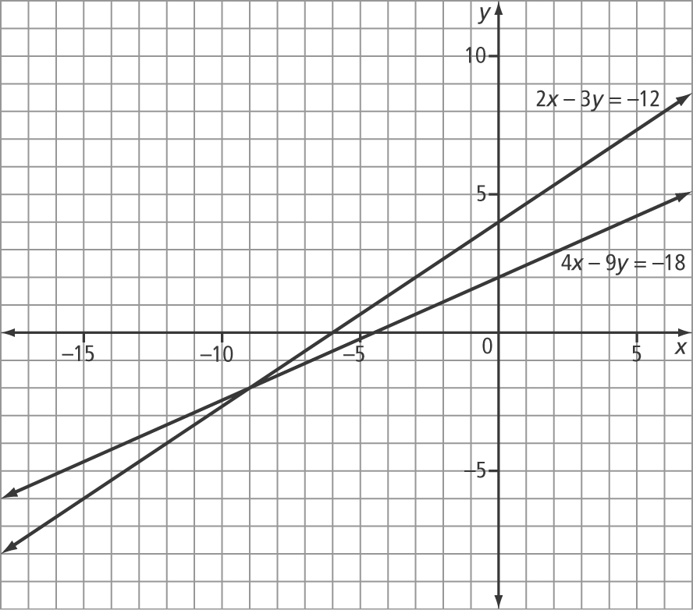
(–9, –2)
2. x = 1 and y = 1 3. y = 2 and x = 1
4. x = 1 and y = 2 5. A

