Algebra Tiles (Negative Tiles)
x²-tiles



x-tiles

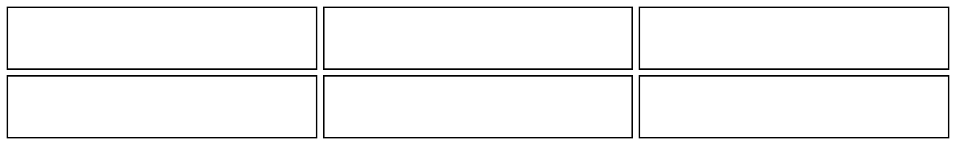

y-tiles

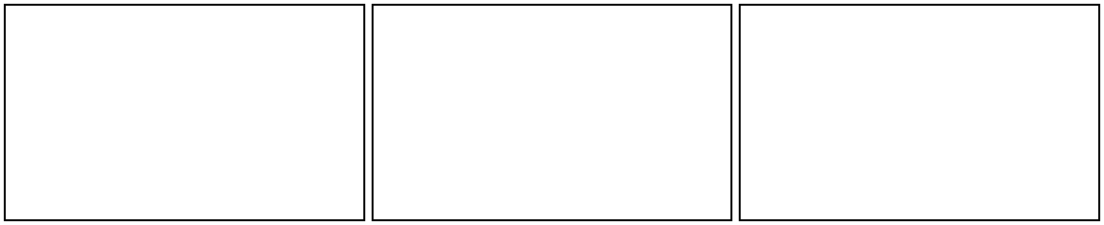

xy-tiles 1-tiles
