Chapter 1 Warm-Up

Section 1.1 Warm-Up
1. Name three instruments that are used to measure length.
2. Estimate in either centimetres or millimetres.
a) the thickness of your student resource
b) the thickness of Chapter 1 in the student resource
3. Use mental mathematics to complete the following operations.
a) 5.2 ÷ 102
b) 371 × 103
c) 1.85 × 104
d) 2.78 ÷ 105

4. What is the value of x in each ratio?
a) = b) 3 : x = 9 : 15
c) = d) 2 : 8 = x : 24
5. Estimate the circumference of each circle. Then, calculate the circumference to the nearest tenth of a centimetre.
a) 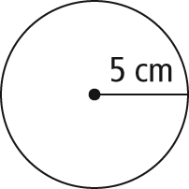

b) 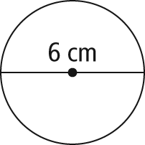

Section 1.2 Warm-Up
1. What is your height, in feet and inches?
2. A line has been divided into equal parts. Match each of the letters to one or more of the following fractions.
, , , , , , , , ,
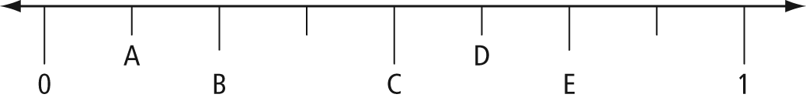
3. Convert each mixed number to an improper fraction.
a) 2
b) 1
c) 3

4. Determine each product without using a calculator.
a) b)
c)
5. What is the length of each unknown side?
a) 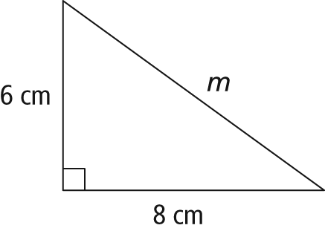
b) 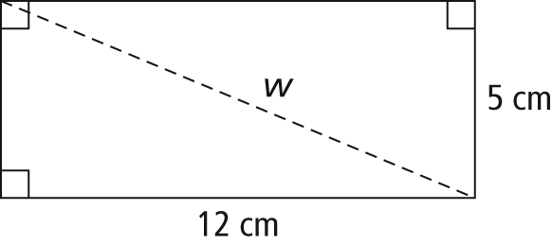

Section 1.3 Warm-Up
1. Fill in the blanks.
a) 48 inches = ______ feet
b) ______ yards = 15 feet
c) 1 mile = ______ yards
2. Fill in the blanks.
a) 1500 cm = ______ m
b) ______ m = 380 cm
c) 50 cm = ______ mm
3. Estimate each of the following measurements.
a) your height in centimetres
b) the length of your thumb in inches
c) the length of your foot in centimetres
4. Show how you would multiply and 2.1 without a calculator.
5. A walkway has a length of 3.5 m and a width of 1.2 m. A decorative planted edge that is
10 cm wide is placed along the longer sides of the walkway.
a) What is the total width of the walkway and the decorative edge?
b) What is the length of the walkway?

