Chapter 1 Unit 1 Project
Section 1.1
1. The music industry involves the production, distribution, and sale of music in a variety of forms. Since the 1960s, music distribution has evolved from vinyl records to cassette tapes, to CDs, and to MP3s. Each change emphasized that smaller is better.
a) For the actual-size cassette shown, use a suitable referent to estimate the dimensions of the cassette case. Explain why you used that referent.
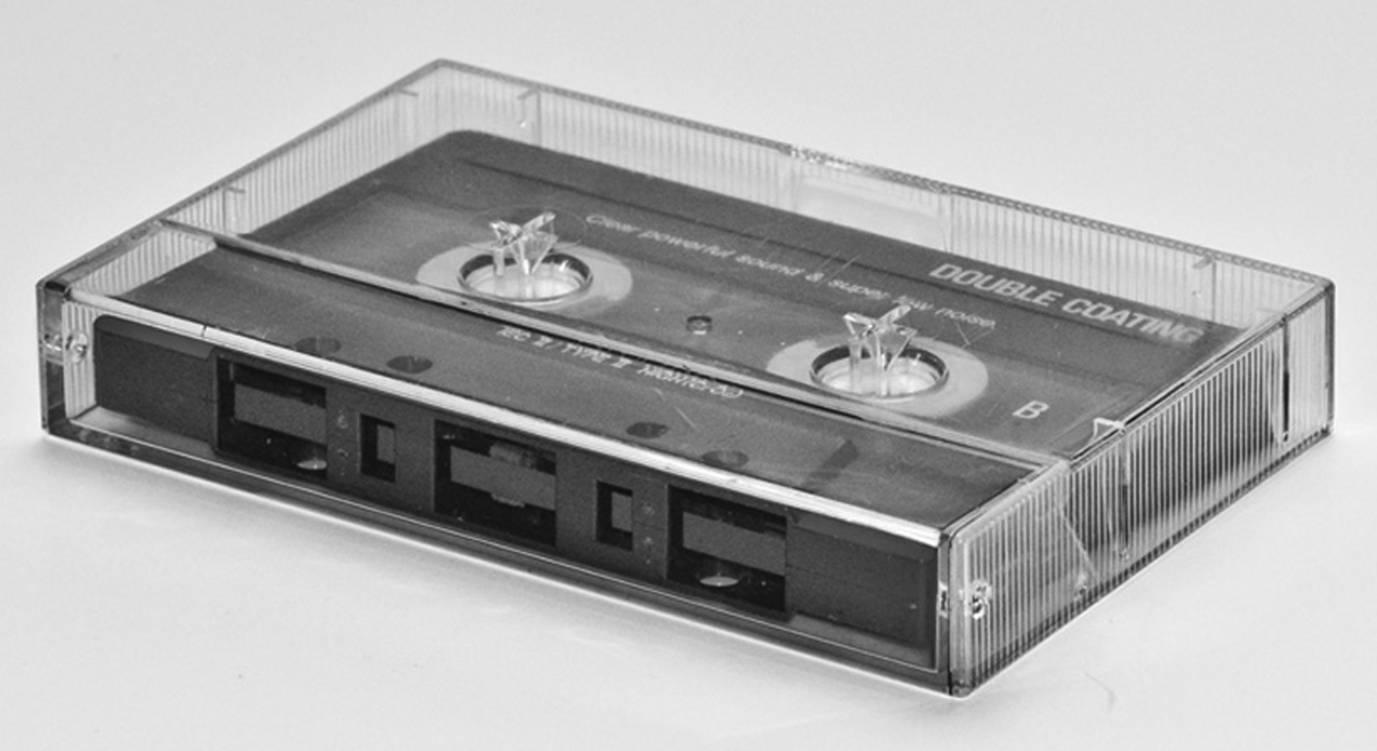
b) Measure and calculate the perimeter of each different face of the cassette case, in millimetres. How many perimeters do you need to calculate?
c) Vinyl records are available in three sizes — 45 rpm (revolutions per minute), 78 rpm, and rpm or LP size. A 45 record has an actual diameter of 17.5 cm. Estimate the diameter of the LP in the photograph using a referent. Then, by measuring and determining a scale, calculate the actual diameter of the LP, in millimetres.
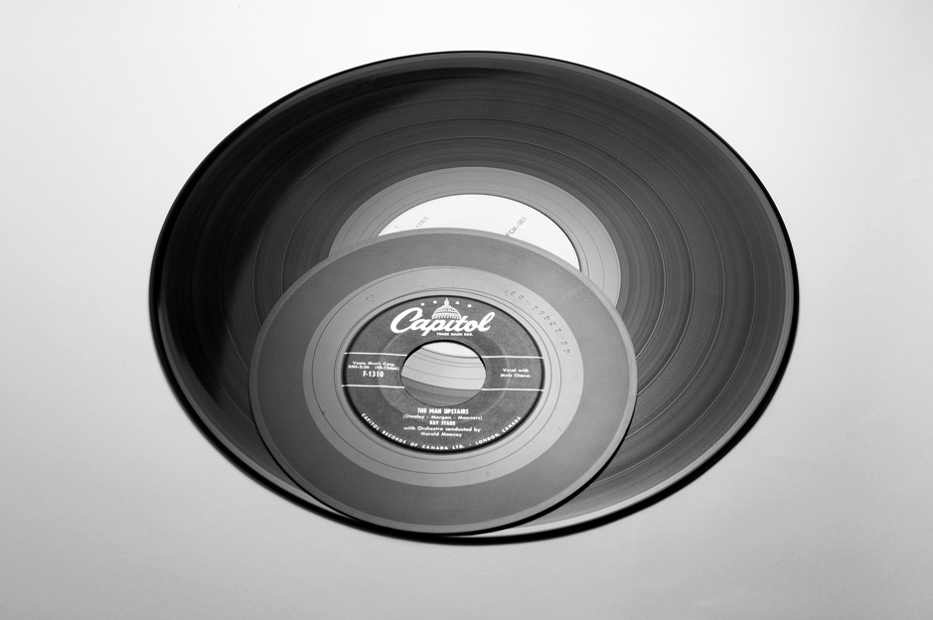
Section 1.2
2. Today’s music storage devices tend to be smaller than those of the past, but they can store many more songs. Find a cassette tape case, a CD, and an MP3 player. Use an imperial unit to measure each of the following dimensions. Justify your choice of unit.
a) the diameter of the CD
b) the dimensions of the cassette case
c) the perimeter of the largest face of the MP3 player
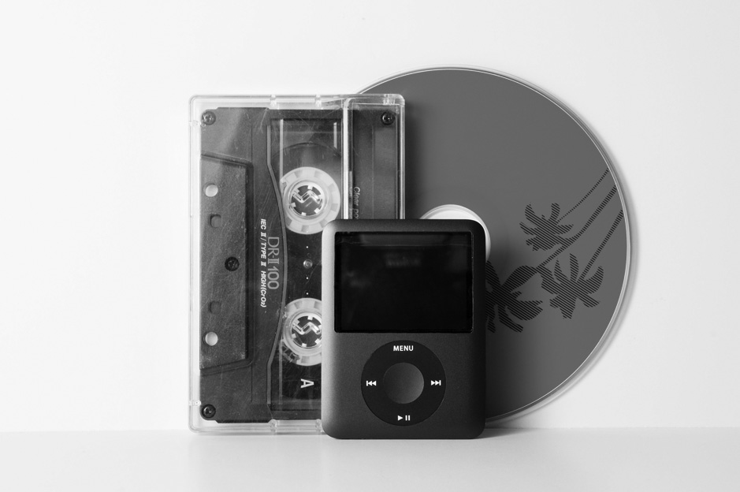
Section 1.3
3. One type of 80 GB MP3 player has dimensions of 4.14 cm (width) by 9.15 cm (height) by 0.85 cm (thickness). The storage capacity is about 20 000 songs. Each LP vinyl record holds an average of
12 songs and is approximately in. thick.
a) Calculate the number of LPs you would need to store as many songs as the MP3 player. Use mental mathematics to show that your answer is reasonable.
b) Suppose you stack the LPs. Calculate the height of the stack. Compare it with the height of the MP3 player. Give your answer as a ratio in lowest terms.

