Section 1.1 Extra Practice

1. What referent would you use to estimate each of the following measurements in SI units?
a) the height of the classroom door
b) the thickness of your calculator
c) the distance from home to school
2. What reading is shown on the ruler at points A, B, C, and D? Give each reading in both centimetres and millimetres.
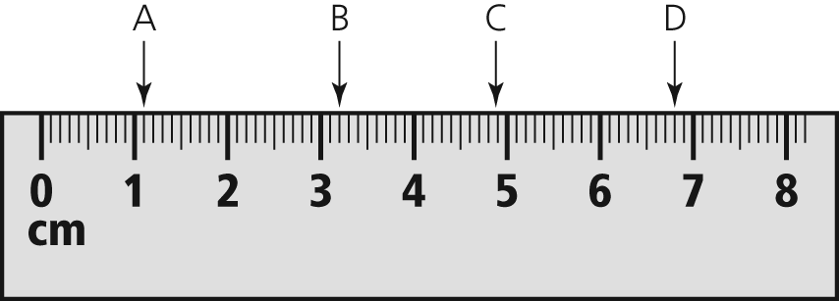
3. What reading is shown on the caliper? Give the reading in both millimetres and centimetres.
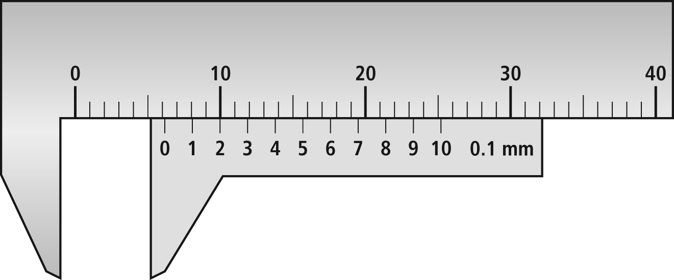
4. A cylindrical gasoline tank has a radius of
28 cm. It is hung to a truck using a metal strap. What is the length of the strap if an extra 5 cm is used at each end for bolts A and B? Express your answer to the nearest centimetre.
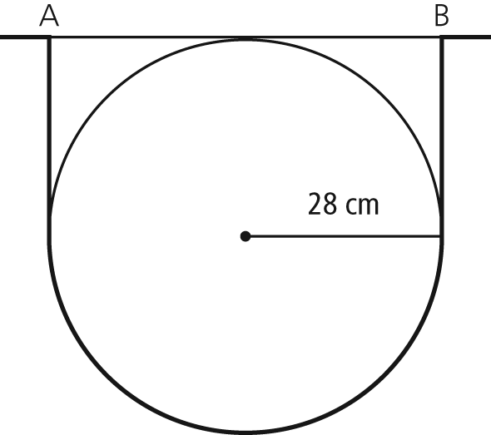

5. The province of Alberta is approximately 1300 km long from the northern border to the southern border.
a) What is the scale for each map of Alberta in the diagram?
b) Determine the width of the province at its northern border and at its southern border, to the nearest 10 km.

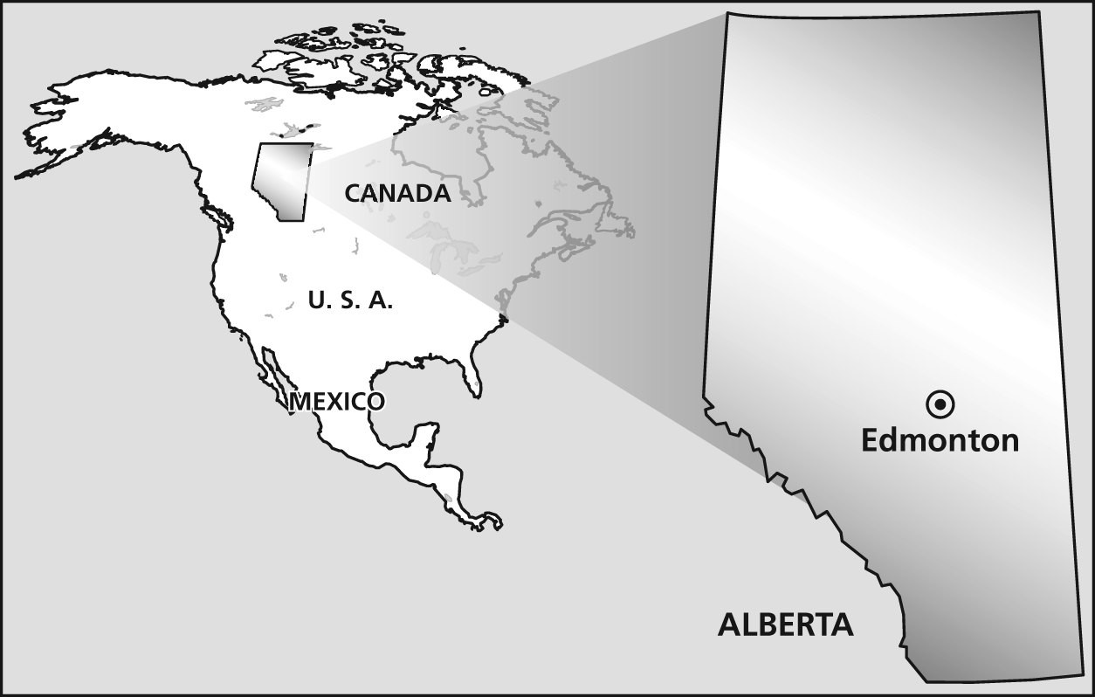
6. Convert each of the following measurements.
a) 7 cm = ______ mm
b) 32 m = ______ cm
c) 58 km = ______ m
d) 75 km = ______ cm
e) 65 000 cm = ______ km
f) 56 m = ______ km
7. State whether you think each measurement is reported in the most appropriate unit. If not, explain why and convert it to a more appropriate SI unit.
a) The length of a housefly is 0.005 m.
b) The depth of the Pacific Ocean is
4 188 000 mm.
c) The length of a table-tennis table is
0.002 74 km.
d) The height of the CN Tower in Toronto, Ontario, is 55 300 cm.

