Section 1.2 Extra Practice

1. What reading is shown on the imperial ruler below at points A, B, C, and D?
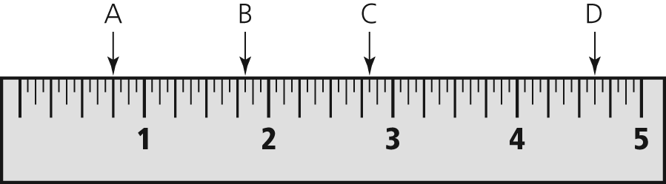
2. What reading is shown on this imperial caliper?
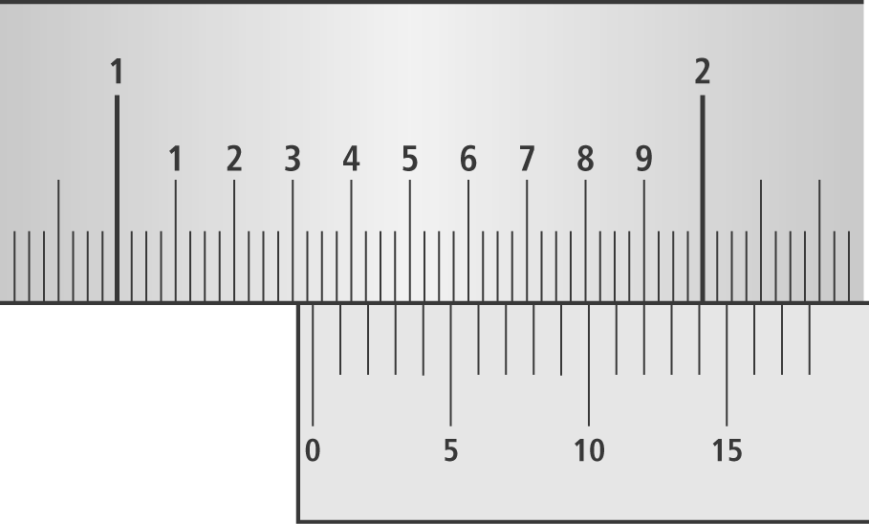
3. Convert each measurement to the unit indicated.
a) 72 inches = ____________ feet
b) 3 miles = __________ feet
c) 5' 10" = ___________ inches
d) 4400 yards = _________ miles
e) 500 inches = ______________ feet and _________ inches
4. Convert each measurement to the unit indicated.
a) Mount Everest is 29 028 ft high.
(nearest quarter of a mile)
b) The width of a calculator is ft.
(nearest eighth of an inch)
5. According to Guinness World Records, the longest total length of the fingernails for a female is 9 yd.
a) Convert the measurement to the nearest half of an inch.
b) Calculate the average length of each fingernail, to the nearest inch.
6. In the diagram, the window on top is semicircular. The rectangular window in the middle measures 28 in. by 55 in. The two side windows measure 16 in. by 55 in. Calculate the perimeter of the windows. Express your answer in feet and inches.
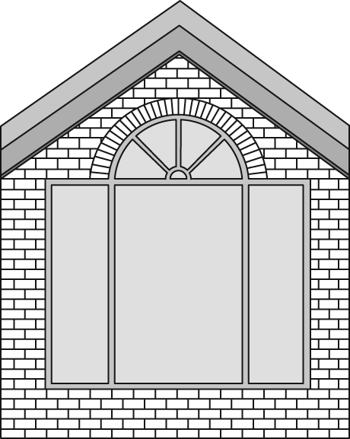
7. On a recent trip to Butchart Gardens in Victoria, BC, Mary took a photograph of a flower that measures 4 in. by 6 in. She wants to enlarge a copy of the photo for the frame below.
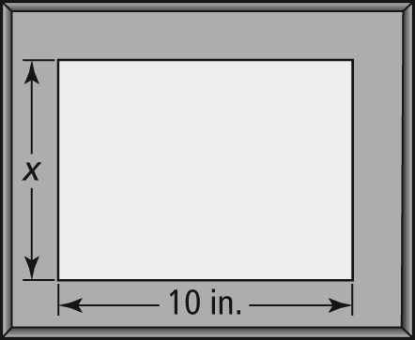
a) What is the length of the unknown side of Mary’s frame? Hint: You will need to use a ruler.
b) By what scale factor will Mary need to enlarge the photo?
c) Calculate the dimensions of the enlarged photo.

