Section 1.3 Extra Practice

1. Convert each measurement to the unit specified.
a) The mean radius of Earth is 6400 km. (nearest hundred miles)
b) The size of a dust particle is 0.004 in. (nearest tenth of a millimetre)
c) In baseball, the distance from home plate to the pitcher’s mound is 60 ft 6 in. (nearest hundredth of a metre)
d) The distance from Edmonton to Calgary is 184 mi. (nearest kilometre)
2. A rectangular flower bed has a border of grass that is ft wide. The outside dimensions of the grass are ft by ft. Calculate the dimensions of the flower bed in inches and in centimetres.
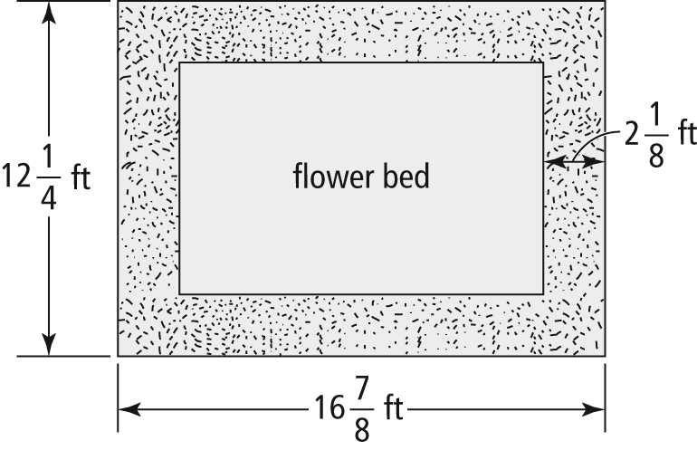
3. Consider the myth that long-tailed, South American monkeys cling to each other forming a bridge between trees. Suppose a monkey chain contains 17 monkeys, each one extending 3 ft.
a) Estimate the length of the chain in feet. Predict whether the actual length is greater than your estimate. Explain your reasoning.
b) What SI unit would be most appropriate for measuring the length of the monkey chain?
c) Calculate the length of the monkey chain in the unit you selected in part b). Express your answer to the nearest tenth of a unit.
4. A toy car is being measured.
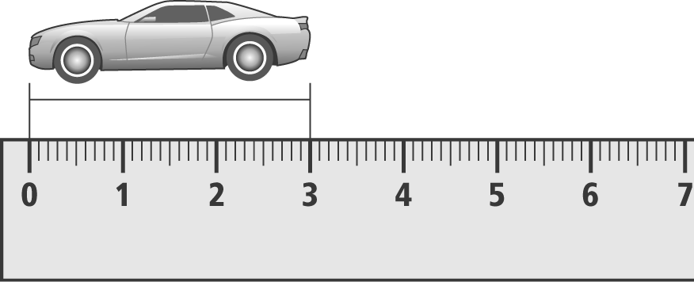
a) Identify the unit represented on the ruler.
b) Measure the length of the toy car, to the nearest tenth of a centimetre and then to the nearest quarter of an inch.
c) Calculate the height to length ratio of the car, to the nearest hundredth of a unit.
5. The Longs travelled, from Lethbridge, AB, to Great Falls, Montana, to visit friends. The distance from Lethbridge to the Canada-U.S. border is 130 km. The distance, from the border to Great Falls, is 114 miles. Calculate the total distance for the round trip, in both miles and kilometres.
6. Clara is renovating her bedroom. She measures her bedroom to be 3.8 m by 4.1 m. She wants to buy new baseboards and carpet. When she gets to the store, she discovers that baseboards and carpeting are sold in imperial units.
a) Calculate the dimensions of Clara’s room to the nearest quarter of a foot.
b) What is the minimum length of baseboards she requires?
c) Suppose baseboards are sold in 12-ft lengths. How many lengths should Clara purchase (allow 10% extra for cuts and waste)?

