Chapter 1 Test

Multiple Choice
For #1 to #5, select the best answer.
1. Which of the following referents is not appropriate to estimate the specified measurement unit?
A one rotation of a mountain bike wheel, foot
B height at waist level, metre
C width of paper clip, millimetre
D width of pinky finger, half an inch
2. A 42″ TV is recommended if the viewing distance is 10′, a 46″ TV for 12', and a 50″ TV for 14′. Cale and Jess each measured the distance from their couch to their TV in a different manner.
• Cale counted 12 foot lengths and determined they should buy the 46″ TV.
• Jess counted 3 long paces and agreed they should buy the 46″ TV.
Which statement regarding the choice of televisions is true?
A Cale’s personal strategy is more accurate than Jess’s.
B Jess’s personal strategy is more accurate than Cale’s.
C Both Cale and Jess have an accurate strategy.
D Neither Cale nor Jess has an accurate strategy.
3. Suppose the width of your palm is 6.5 cm. How many palm widths do you need to measure an object that is one foot long?
A 3
B 4
C 5
D 6
4. What is the reading on the caliper, in centimetres?
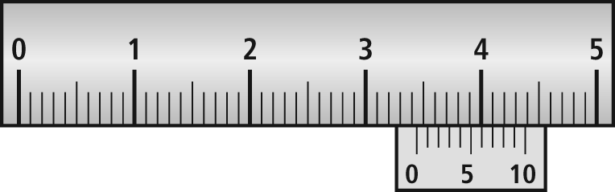
A 3.35 cm
B 3.37 cm
C 3.44 cm
D 3.47 cm
5. Which of the following is not a reasonable conversion between SI and imperial units?
A 1 km0.6 mi
B 10 yd9 m
C 1 m5 ft
D 4 in.10 cm
Short Answer
6. The perimeter of a rectangular room measuring 8′6″ by 9′ is _____ feet.
7. Vlad estimates that his index finger is 3 in. long. He calculates the circumference of one drum of his bongo set to be 24 in. Suppose Vlad uses this referent to measure the circumference. How many finger lengths along the circumference of the drum would he have counted?
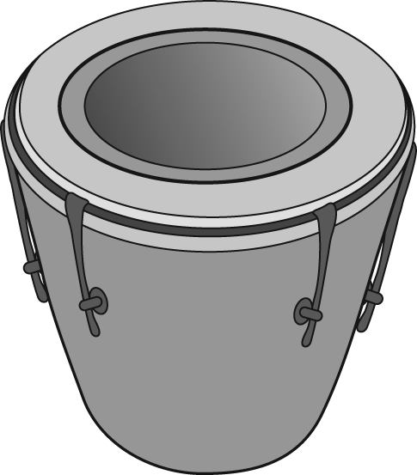
8. The length of a loveseat is 1.5 m and the length of a couch is 2.1 m. Suppose the length of the box on a moving truck is 14 ft. How many linear feet are remaining after the loveseat and couch are placed in the box end to end?
9. Convert each measurement to a more appropriate unit in the SI system.
a) 51 430 cm b) 2650 mm
c) 0.54 m
10. Convert each measurement to the indicated unit.
a) 63 inches = ____ feet
b) 7 yards = ____ inches
11. Write the conversion factor(s) required to convert the following:
a) 6 mi to kilometres
b) 19.2 m to centimetres
c) ft to inches
d) 500 cm to yards
12. Calculate each conversion in #11, to the nearest half of a unit.
Extended Response
13. Alicia and her friends want to estimate the diameter of a Douglas fir tree. They know that a person’s arm span is approximately equal to his or her height. So, they decided to join hands and determine how many people were needed to reach around the circumference of the tree. It takes five people⎯Alicia, 5′ 2″, Tal 5′ 8″, Julia 5′ 6″, Paul 6′ 1″, and Colin 6′ 3″⎯to reach around the tree. What is the radius of the tree, to the nearest inch?
14. Yvon draws a diagram of his backyard. The scale of his diagram is 1 : 400.
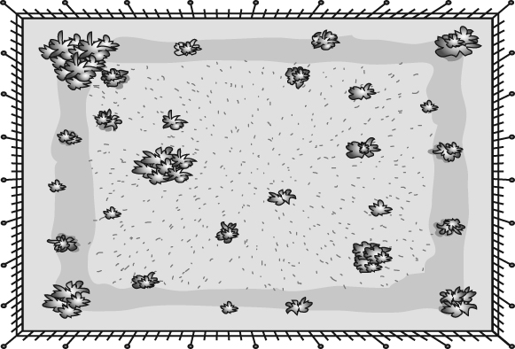
a) What distance on the ground is represented by 2 cm on the drawing?
b) What are the dimensions of the actual yard?
c) Estimate the length of the diagonal in Yvon's drawing of his backyard.
d) Show two ways to calculate the diagonal distance of Yvon’s backyard.
15. Tom made a sketch of some flowers that were sitting on his mother’s dresser.
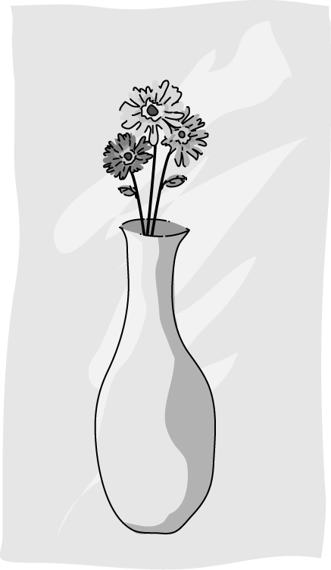
a) Estimate the height of the vase in the drawing in imperial units.
b) Use a referent to estimate the height of the vase in SI units.
c) Measure the height of the vase in centimetres. Then, convert the measurement to inches. How does the converted imperial measurement compare to your estimate?
d) The height of the real vase Tom sketched is 27 cm. If the flowers touch the bottom inside the vase, how tall are the flowers?

