Chapter 1 BLM Answers

BLM 1–2 Chapter 1 Prerequisite Skills
1. a) 100 b) 1000 c) 3500 d) 100 000
2. a) 5.2 cm b) 4.2 cm c) 3.2 cm
3. a) 0.8 cm or 8 mm b) 5.7 cm or 57 mm c) 1 mm
4. 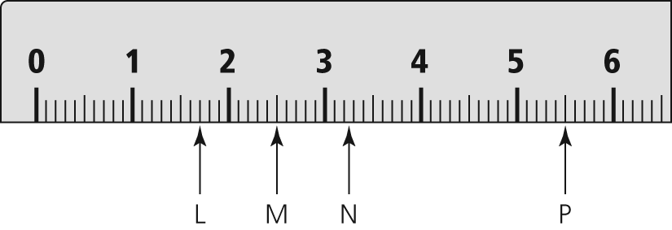
5. a) 3 cm b) 7 cm c) 5 cm
6. a) Scale factor refers to the constant factor by which all dimensions of an object are enlarged or reduced in a scale drawing. For example, if the dimensions of a drawing of a square are enlarged by a factor of 2, then each side of the square is 2 times as long as the original.
b) If the scale factor is less than 1, the diagram is a reduction.
c) 1:1.45
7. a) 8 b) 16 c) 8 d) 32
8. = 0.625
9. a) x = 10 b) x = 7.5. Example: If you look at the numerators, you can see that you can get from 2 to 3 by multiplying by 1.5. Then, you do the same with the denominators.
c) x = 1.25 d) x = 22.5
10. a) 25.8 cm b) 8x mm c) 50.27 cm
11. a) 3 cm 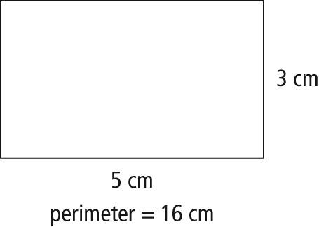
b) 7.2 mm 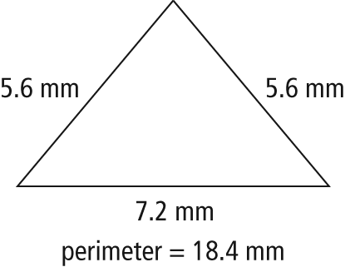
c) 5.7 m 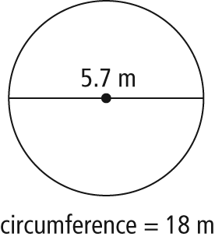
BLM 1–3 Chapter 1 Warm-Up
Section 1.1
1. Example: ruler, odometer, measuring tape
2. a) Example: 2.7 cm or 27 mm b) Example: 0.4 cm or 4 mm
3. Examples: a) 0.052 b) 37 100 c) 185 d) 0. 0278
4. a) 19 b) 5 c) 0.15 d) 6
5. a) Estimate: Example: 30 cm; calculate: 31.4 cm
b) Estimate: Example: 18 cm; calculate: 18.8 cm
Section 1.2
2. A: ; B: , ; C: , , ; D: , E: ,
3. a) b) c)
4. a) 35 b) or c) 60
5. a) 10 cm b) 13 cm
Section 1.3
1. a) 4 b) 5 c) 1760
2. a) 15 b) 3.8 c) 500
4. Example: Change to , and 2.1 to , which becomes . Then, multiply.
5. a) 1.4 m or 140 cm b) 3.5 m
BLM 1–5 Section 1.1 Extra Practice
1. Examples: a) waist height ≈ almost 1 m
b) width of fingernail ≈ 1 cm
c) ten city blocks ≈ 1 km
2. A: 1.1 cm = 11 mm, B: 3.2 cm = 32 mm,
C: 4.9 cm = 49 mm, D: 6.8 cm = 68 mm
3. 6.2 mm = 0.62 cm
4. 154 cm
5. a) large map: 1:27 083 333,
small map: 1:216 666 666
b) northern border approx. 600 km, southern border approx. 300 km
6. a) 70 mm b) 3200 cm c) 58 000 m
d) 7 500 000 cm e) 0.65 km f) 0.056 m
7. a) 5 mm b) 4188 m or 4.188 km
c) 2.74 m d) 553 m
BLM 1–6 Section 1.2 Extra Practice
1.
2. 1.312 in.
3. a) 6 feet b) 15 840 feet c) 70 inches
d) 2 miles e) 41 feet 8 inches
4. a) 5 miles b) inches
5. a) inches b) 34 inches
6. perimeter = 20 feet
7. a)in. b) 1.875 = c)
BLM 1–7 Section 1.3 Extra Practice
1. a) 4000 mi b) 0.1 mm c) 18.44 m d) 296 km
2. 96 inches by inches ; 244 cm by 385 cm
3. a) Estimate: 45 ft = 15 × 3. Actual answer is greater because 17 > 15.
b) Example: metre c) 15.5 m
4. a) centimetres b) 3.0 cm = inch
c) 1:3.33 cm
5. 627 km = 390 mi
6. a) 12 ft by 13 ft b) 52 feet
c) 5 lengths
BLM 1–8 Chapter 1 Test
1. C 2. A 3. C 4. D 5. C 6. 35 7. 8
8. 2 ft
9. a) 514.3 m b) 2.65 m c) 54 cm
10. a) b) 252 in.
11. a) 1 mi1.609 km
b) 1 m = 100 cm
c) 12 in. = 1 ft
d) 100 cm = 1 m and 1 yd = 0.9144 m
12. a) 9.5 km b) 1920 cm c) 54 in. d) yd
13. 55 in.
14. a) 800 cm or 8 m
b) 12 m by 18 m
c) estimate: 5.5 cm
d) Method 1: Measure the length of the diagonal in the diagram or use the Pythagorean theorem to calculate the length of the hypotenuse in the drawing. Then, use the scale to calculate the actual distance.
=
Method 2: Use the measurements calculated
in part b) and apply the Pythagorean theorem.
15. a) estimate: in.
b) referent: width of 1 fingernail1 cm
estimate: 3 cm
c) 3 cm = in. Estimate is slightly greater than measurement.
d) 40.5 cm

