Chapter 2 Test
Multiple Choice

For #1 to 6, select the best answer.
1. What are the most appropriate SI and imperial units for expressing the area of a banquet hall floor?
A m² and ft²
B m² and yd²
C km² and ft²
D km² and mi²
2. What is the minimum amount of wrapping you would need to cover the gift box shown here?
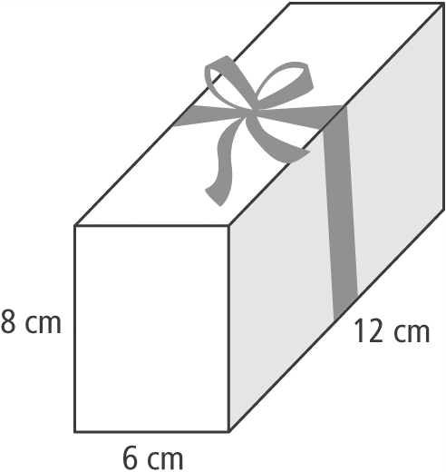
A 216 cm²
B 408 cm²
C 432 cm²
D 576 cm²
3. A rectangular pyramid has a base 3 cm by
6 cm and a height of 9 cm. What are the dimensions of a rectangular prism with an equivalent volume?
A 1 cm by 2 cm by 3 cm
B 2 cm by 4 cm by 6 cm
C 2 cm by 3 cm by 9 cm
D 3 cm by 6 cm by 9 cm

4. Calculate the surface area of the pyramid to the nearest square inch.
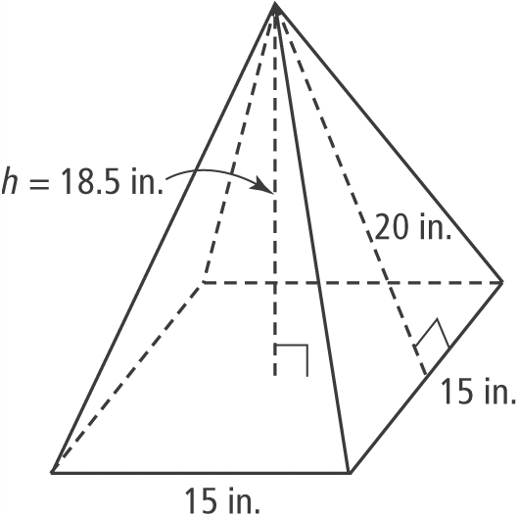
A 1500 in.²
B 1387 in.²
C 825 in.²
D 780 in.²
5. Skateboarders use half pipes, which are shaped like half cylinders.
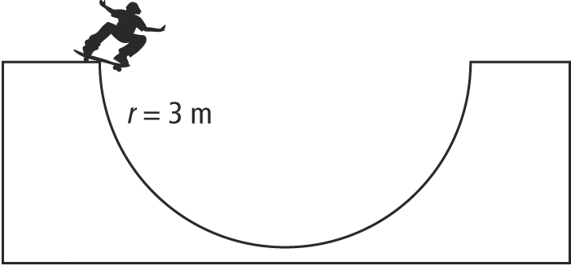
To the nearest square metre, what is the curved surface area of the half pipe if it is 7 m deep?
A 33 m²
B 66 m²
C 132 m²
D 160 m²
6. Scientists at NASA have built a robot called Personal Satellite Assistant or PSA to assist astronauts on board a spacecraft. PSA is in the shape of a sphere and has a diameter of 12 in. To make it more efficient, NASA wants to reduce its diameter to 8 in. To the nearest cubic inch, the difference in volume would be
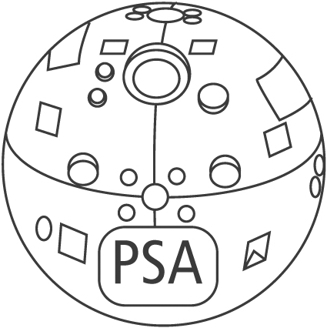
A 996 in.³
B 905 in.³
C 771 in.³
D 637 in.³
Short Answer
7. A cone has a height of 8 m, a slant height of 9.4 m, and a radius of 5 m.
a) Determine the surface area of the cone, to the nearest tenth of a square metre.
b) Determine the volume of the cone, to the nearest tenth of a cubic metre.
8. What is the radius of a sphere with surface area of 804.2 cm²?
Extended Response
9. The shaded area represents a 2-yd wide trench dug by a contractor at a building site. If the contractor removed 182 yd³ of soil, how deep is the trench?
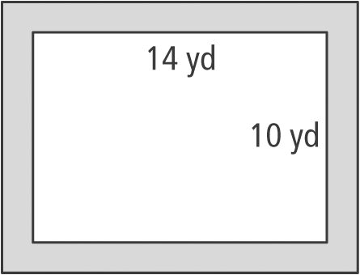

10. Two cones have the same height. Cone A has a radius of 4 cm and a volume of
92.15 cm³. Cone B has a radius of 7 cm.
a) What is the height of the cones?
b) What is the volume of Cone B?
c) If the radius of Cone A is increased by
3 cm, what is the volume relationship between the new cone and Cone B?
11. A storage container for radioactive material has the dimensions shown below.
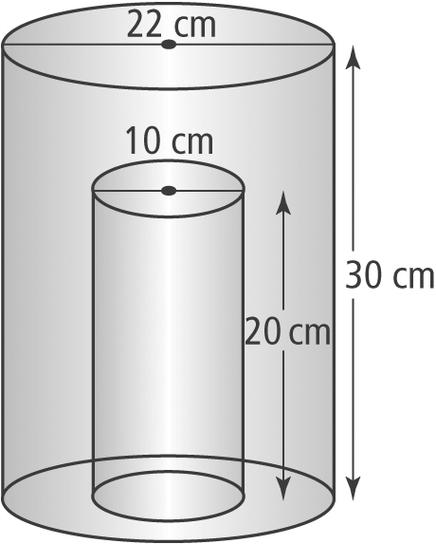
a) To the nearest cubic centimetre, what is the volume of the inside storage compartment?
b) The outside of the storage container needs to be sealed with a protective coating. Excluding the bottom, what is the area that needs to be coated, to the nearest square centimetre?

