Chapter 2 BLM Answers
BLM 2–2 Chapter 2 Prerequisite Skills

1.
Surface Area | Volume
a) 3324 cm²; 515.2 in.² | 11 880 cm³; 725.0 in.³
b) 433.5 cm²; 67.2 in.² | 614.1 cm³; 37.5 in.³
c) 484 in.²; 3122.6 cm² | 665.5 in.³; 10 905.6 cm³
2.
Surface Area | Volume
a) 452.4 in.²; 2918.6 cm² | 703.7 in.³; 11 531.9 cm³
b) 22 776.5 cm²; 3530.4 in.² | 235 619.4 cm³;  14 378.4 in.³
c) 24 328.5 cm² ; 3770.9 in.² | 267 613.4 cm³;  16 330.8 in.³
d) 251.6 cm²; 39.0 in.² | 271.8 cm³; 16.6 in.³
e) 485.0 in.²; 3128.9 cm² | 748.6 in.³; 12 267.1 cm³
3. Students should sketch each 3-D object.
Surface Area | Volume
a) 1226.9 cm² | 2924.2 cm³
b) 128.3 in.² | 91.1 in.³
c) 21 134.2 cm² | 186 902.2 cm³
d) 5261.1 cm² | 25 192.2 cm³
e) 2049.9 in.² | 6361.7 in.³
f) 7783.2 cm² | 26 825.7 cm³
4. a) 9 b) 5.48 c) 3.46 d) 8.12 e) 39.86
5. 2 m; Answers will vary. Example: a shipping box for a washing machine
6. 5 cm; Answers will vary. Example: a jewellery box for a ring
BLM 2–3 Chapter 2 Warm-Up
Section 2.1
1. a) For Ed’s project, using large units, such as kilometres results in very small numbers. It would be more appropriate to measure in metres and centimetres. b) 23.8 m; 17.9 m
2. a) Use inches or feet, as they are smaller units than yards but large enough that most measurements can be expressed as whole numbers.
b) Students may convert all measurements to inches or feet.

13 in. | 3.75 ft | yd
13 in. | 45 in. (3 ft = 36 in.) + (0.75 ft = 9 in.) | 12 in.  (1 yd = 36 in.)
1 ft 1 in.  (12 in. = 1 ft) | 3.75 ft | 1 ft  (1 yd = 3 ft)
3. Example:
- Convert 180.3 cm by 101.6 cm to approximately
71 in. by 40 in. or 5.9 ft by 3.3 ft.
- Estimate the area to be about 6 ft by 3 ft or 18 ft².
- Estimate the cost to be at least (18)(75) = $1350.
4. Area is the number of square units needed to cover a surface. For example, 47 m² means 47 squares each with side length 1 m and area 1 m².
5. Volume is the amount of space that an object occupies.
Section 2.2
1. a) 90 000 cm². 1 m = 100 cm
b) 144 in.². 1 ft = 12 in.
2. 176 in.²
3. a)
Dimensions | 1 by 17 | 2 by 16 | 3 by 15 | 4 by 14 | 5 by 13 | 6 by 12 | 7 by 11 | 8 by 10 | 9 by 9
Area (m²) | 17 | 32 | 45 | 56 | 65 | 72 | 77 | 80 | 81
b) 9 m by 9 m gives the largest area.
4. The diameter of the circle is the length of one square multiplied by 7, as the squares and the line segments that connect them are equal in length. Half of the diameter is the radius. Substitute the value of the radius in the formula SA = πr² to solve the area of the circle. Then, subtract the area of the squares (or 3 times the area of one square) to find the area of the shaded portion.
5. a) 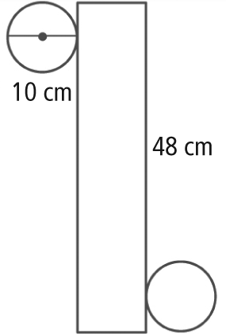
b) 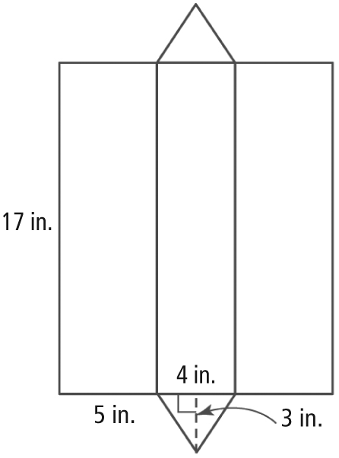
Section 2.3
1. Volume is the number of cubes that fill the space that an object occupies. For example, 4m³ is made up of four 1-m³ cubes. Each cube is 1 m in length by 1 m in width by 1 m in depth.
2. 1 m = 100 cm, 1 000 000 cm³
3. Using the Pythagoras relationship, c² = a² + b² ; 8² = 4² + h² ; height = 6.9 cm
4. 6 cm
5. Add the sum of the volumes of the square-based pyramid and the three prisms.
BLM 2–6 Section 2.1 Extra Practice
1. a) 7.4 m² b) 23 cm² c) 16 000 000 m² d) 180 m³
2. a) 0.9 ft² b) 100.8 in² c) 4 yd² d) 1.7 ft³
3. a) 77.4 cm² b) 3.6 yd² c) 0.8 cubic mi d) 0.1 m³
4. a) 45 cm³ b) 442.5 cm³
5. a) 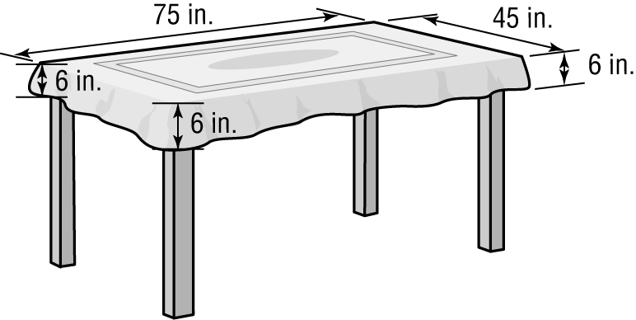
b) 87 in. by 57 in. c) 3.2 m²; It will take 3.2 m² of fabric to make the tablecloth.
6. 4.9 yd³; It will take 4.9 yd³ of sand to fill the sandpits.
7. a) 908 cm²; The area of the platform top is
908 cm².
b) smaller by approximately 21.1 cm²
8. 42 in. or 3' 6"; The floor measures 42 in. or 3' 6" in width.
BLM 2–7 Investigate Surface Area of Three-Dimensional Objects
1., 2. Example:
Quadrant 1: The sum of the surface areas of all faces of a 3-D object.
Quadrant 2: Find the area of each face, and then add all the areas.
Quadrant 3: Students use strategies of their choice. They record the strategies and the results.
Example: The surface area of the cylinder is 374.7 cm². The surface area of the cone is 208.6 mm². The surface area of the prism is 348 in.².
Quadrant 4: Expect a different strategy from the one shown in Quadrant 3.
BLM 2–8 Section 2.2 Extra Practice
1. a) 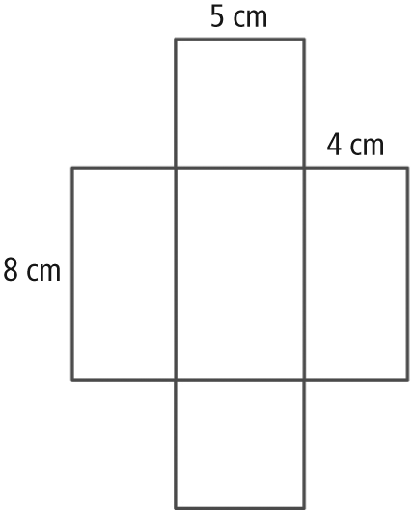
b) 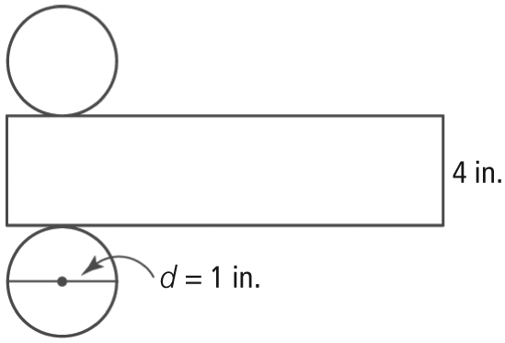
c) 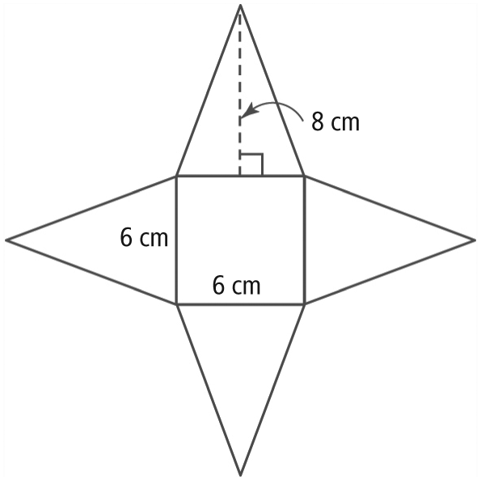
2. a) 184 cm² b) 31.4 in.² c) 132 cm²
3. a) 248.8 cm²
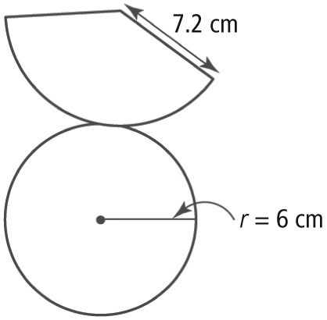
b) 6985.9 cm²
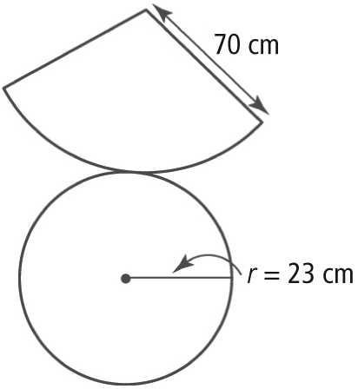
4. a) 6.3 m²
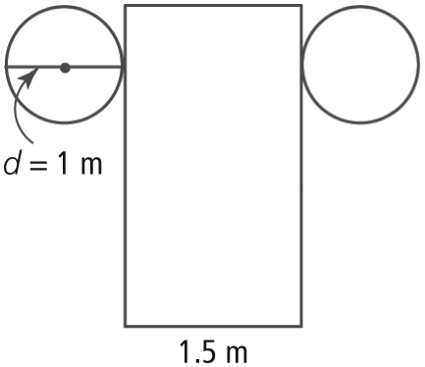
b) 62.8 in^{.2}
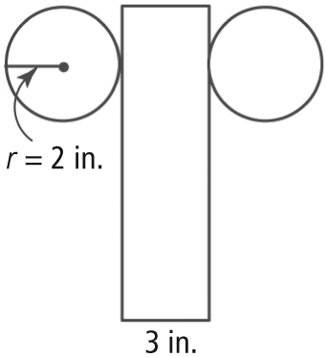
5. a) 96 cm² b) 3124 in.² c) 187.4 in.²
6. a) 320 mm² b) 153.9 in.²
7. a) 20.0 mm b) 23.0 c) 35.0 cm
8. 127.2 ft²
9. front: 64 in.²; sides: 16 in.², light cover: 12.6 in.²; total surface area: 80 – 12.6 = 67.4 in.². He will need to paint an area 67.4 in.².
BLM 2–9 Section 2.3 Extra Practice
1. a) 280 in.³ b) 3000 cm³ c) 114.5 m³ d) 508.9 in.³
e) 1026.3 mm³ f) 284.8 cm³
2. 8.8 in. The microwave is 8.8 in. tall.
3. 2144.7 cm³. The volume of the globe is 2144.7 cm³.
4. 11.5 in. The beach ball is 11.5 in. in diameter.
5. a) 1.5 m b) 4 cm c) 0.75 ft d) 12.0 cm
6. 1.02 ft³
7. base: 12 in.³; roof: 9 in.³; total volume: 21 in.³. The total volume of wood used is 21 in.³.
8. a) 1 in. The sphere is 1 in. in diameter.
b) 4 in. The pyramid is 4 in. in height.
c) 1.5 in. The pyramid base is 1.5 in. wide.
d) 22.5 in.³ The volume of packaging needed is 22.5 in.³.
BLM 2–10 Chapter 2 Test
1. A 2. C 3. C 4. C 5. A 6. D
7. a) 226.2 m² b) 209.4 m³
8. 8 cm 9. 1.625 yd
10. a) 5.5 cm³ b) 282.2 cm³ c) approximately
3 times as great
11. a) 1571 cm³ 524 cm³
b) 2453.6 cm² 2454 cm²

