Chapter 2 Warm-Up
Section 2.1 Warm-Up
1. Ed wants to put siding on a storage building. He measures the outside walls and records wall lengths 0.0238 km and 0.0179 km.
a) Explain why kilometres is not an appropriate measurement unit for
Ed’s purpose.
b) Rewrite the measurements using appropriate metric units.
2. Jaspreet wants to build a flower box with the following dimensions. First, she needs to convert all measurements to the same units.
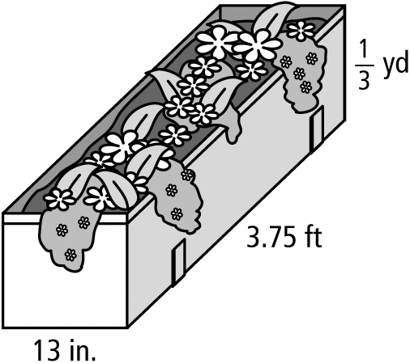
a) What imperial units do you recommend? Explain why.
b) Convert all the measurements to the same units. Explain how you did each conversion.

3. Teresa wants to install a countertop on an island in her kitchen. The dimensions of the island are 180.3 cm by 101.6 cm. Explain how she could estimate the cost if granite costs $75 per square foot.
4. Explain why area is always expressed in square units.
5. Define volume in your own words.

Section 2.2 Warm-Up

1. Convert the following to the indicated equivalents. Justify each answer.
a) an area that is 3 m by 3 m to cm²
b) an area that is 1 ft by 1 ft to in.²
2. A drum has a circumference of 47 in. What is the surface area of the top of the drum, to the nearest whole number?
3. a) A farmer has 36 m of fencing, all in 1 m sections. If he does not cut any of the sections, what are the dimensions of all the different rectangular sheep pens he can make?
b) Which dimensions will give the biggest area?
4. Explain how to find the area of the shaded portion of the circle.
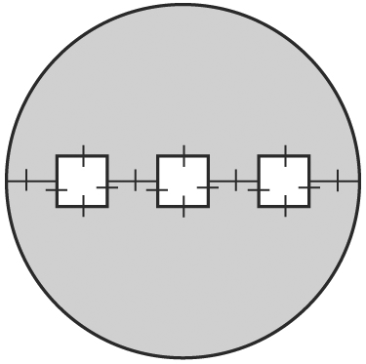
5. Draw the net for each 3-D object. Label all the dimensions.
a) 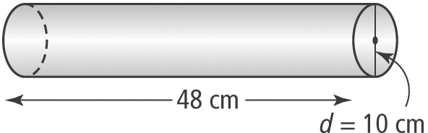

b) 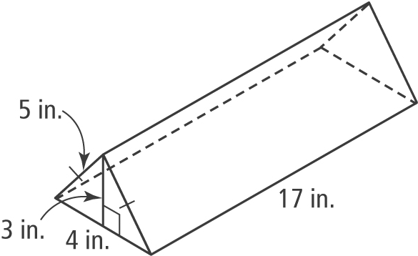

Section 2.3 Warm-Up

1. Explain why volume is measured in cubic units.
2. Convert 1 m³ to cm³. Justify your answer.
3. Calculate the height of the triangle to the nearest tenth. Explain your answer.
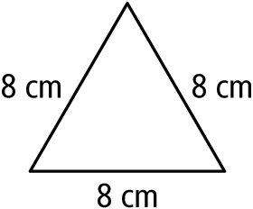
4. Use the formula SA = h(a + b) to determine the height of a trapezoid with area 21.9 cm² and parallel side lengths 4.5 cm and 2.8 cm.
Hint: Draw a diagram.
5. What strategy would you use to find the volume of this composite 3-D object if the dimensions were given?
