Chapter 2 Foldable
Copyright © 2009, McGraw-Hill Ryerson Limited, a subsidiary of the McGraw-Hill Companies. All rights reserved.
This page may be reproduced for classroom use by the purchaser of this book without the written permission of the publisher.
Linear Conversions  If I know the dimensions of an area in one unit, I can convert the area to another unit by  Surface Area Formulas |  | Volume Conversions  If I know the dimensions of a volume in one unit, I can convert the volume to another unit by  Volume Formulas
  Imperial Unit | SI Unit
  1 in. | 2.54 cm
  1 ft | 30.48 cm
  1 ft | 0.305 m
  1 yd | 0.914 m
  1 mi | 1.609 km
  SI Unit | Imperial Unit
  1 cm | 0.394 in.
  1 m | 1.094 yd
  SI Unit | Imperial Unit
  1 cm³ | 1 mL
  1000 cm³ | 1 L

Surface Area:
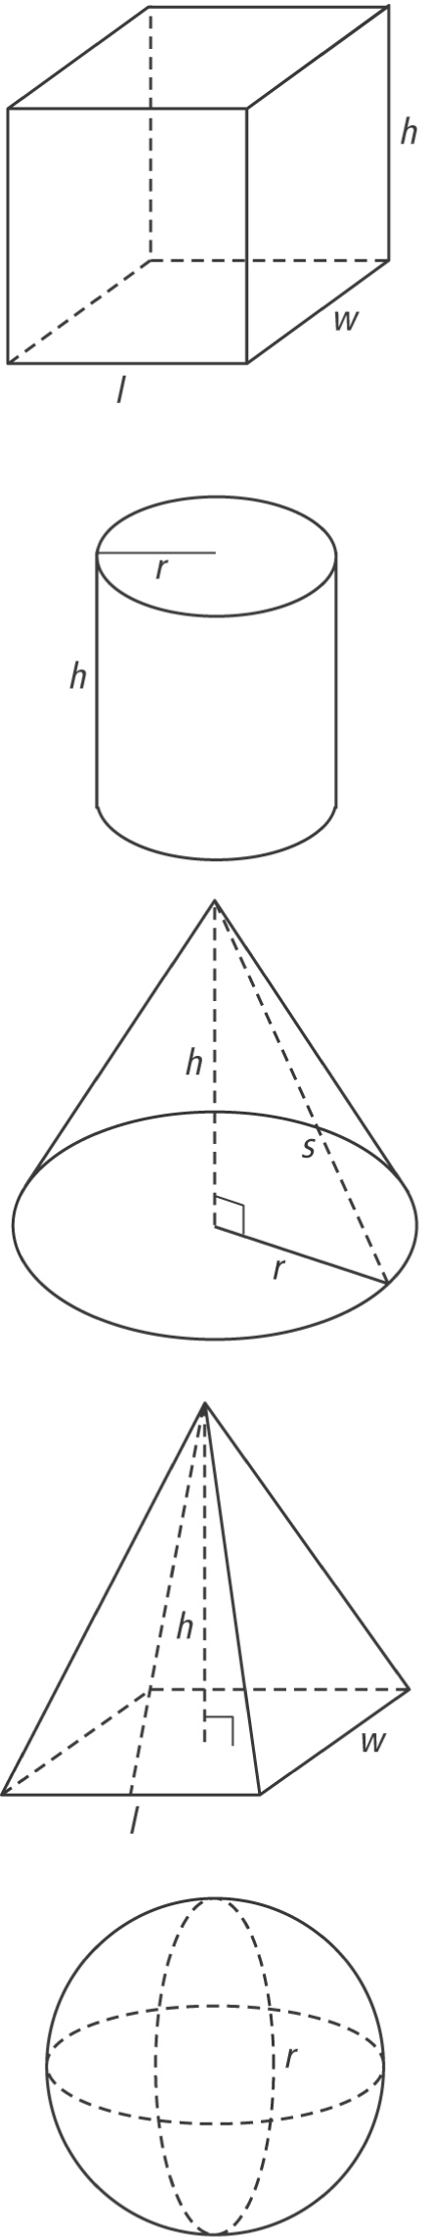
lateral area:
slant height:

Volume:
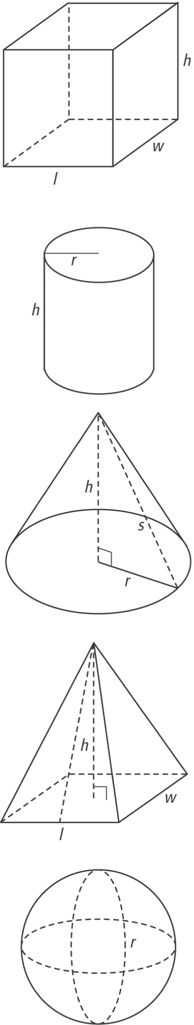
apex:

