Section 2.1 Extra Practice

For help with unit conversions, refer to the conversion charts in your Foldable™.
1. Convert the SI measurements to the indicated equivalents.
a) an area 250 cm by 296 cm to square metres
b) an area 50 mm by 46 mm to square centimetres
c) an area 4 km by 4 km to square metres
d) a volume 900 cm by 1000 cm by 200 cm to cubic metres
2. Convert the imperial measurements to the indicated equivalents. Express your answers to the nearest tenth of a square or cubic unit.
a) an area 13.5 in by 10 in. to square feet
b) an area 3.5 ft by 0.2 ft to square inches
c) an area 4 ft by 9 ft to square yards
d) a volume 28.6 in. by 10 in. by 10 in. to cubic feet
3. Convert the measurements to the indicated equivalents. Express your answers to the nearest tenth of a square or cubic unit.
a) an area 3 in. by 4 in. to square centimetres
b) an area 3 m by 1 m to square yards
c) a volume 1.75 km by 2 km by 1 km to cubic miles
d) a volume 2.5 ft by 2 ft by 1 ft to cubic metres
4. For each 3-D object, calculate the volume in cubic centimetres.
a) a prism with sides measuring 7.5 cm, 3 cm, and 2 cm
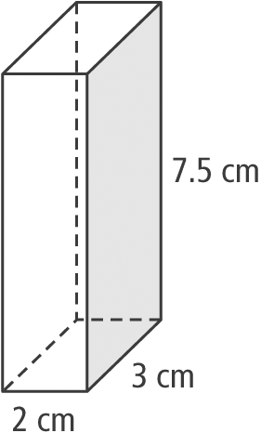

b) a cube with sides measuring 3 in.
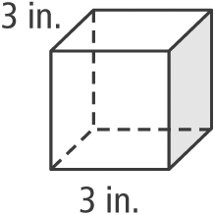
5. Marielle is helping her mother sew a tablecloth. The table has a length of 75 in. and a width of 45 in. An overhang of 6 in. is needed on each side of the table.
a) Sketch and label a diagram to represent the tablecloth.
b) What are the dimensions of the tablecloth in inches?
c) Marielle and her mother go shopping to order fabric for the tablecloth. The fabric is sold in square metres. Determine the amount of fabric needed in square metres, to the nearest tenth of a square metre.
6. The sandpits for a new long jump and a triple jump will each have dimensions 1.5 m by 5 m and be 0.5 m deep. The local landscaping store sells sand by the cubic yard. Calculate the volume of sand required for the pits, to the nearest tenth of a cubic yard.
7. The revolving circular platform in a microwave has a diameter of 34 cm.
a) What is the area of the top of the platform in square centimetres?
b) Is the area larger or smaller than one square foot? By how much?
8. A tile installer is laying files in a bathroom. If the area of the rectangular floor to be tiled is 2688 in.² and the floor length is 5'4", how wide is the floor?

