Section 2.2 Extra Practice

1. Sketch a net for each 3-D object.
a) 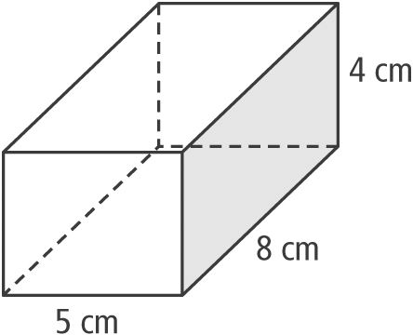
b) 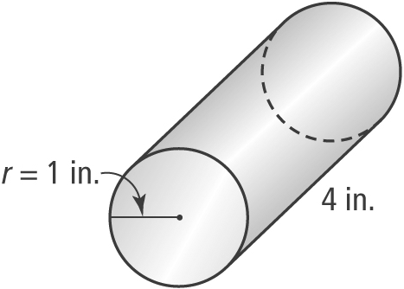
c) 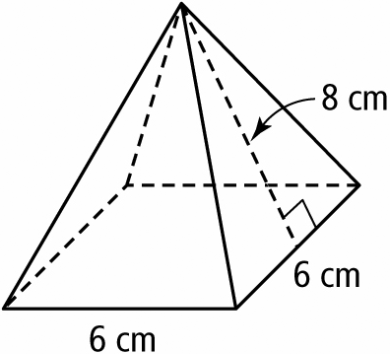
2. Calculate the surface area of each object
in #1.
3. Sketch a net for each cone. Then, determine the surface area of each cone. Round the answer to the nearest tenth of a square unit.
a) 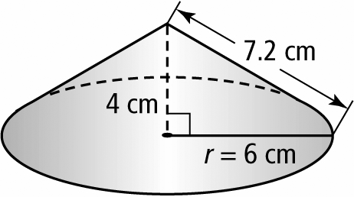
b) 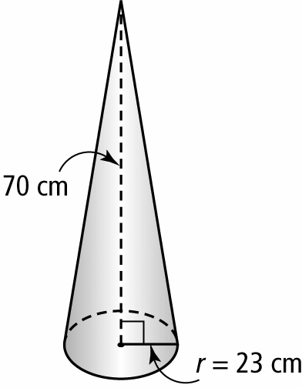
4. Sketch a net for each cylinder. Then, calculate the surface area of each cylinder. Round the answer to the nearest tenth of a square unit.
a) 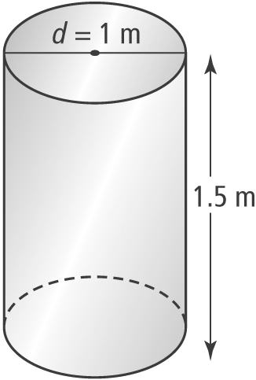
b) 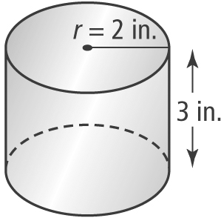
5. Determine the surface area of each right pyramid. Round the answer to the nearest tenth of a square unit.
a) 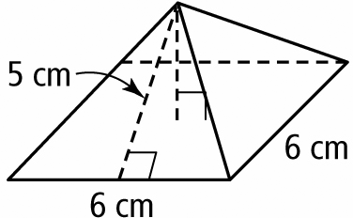
b) 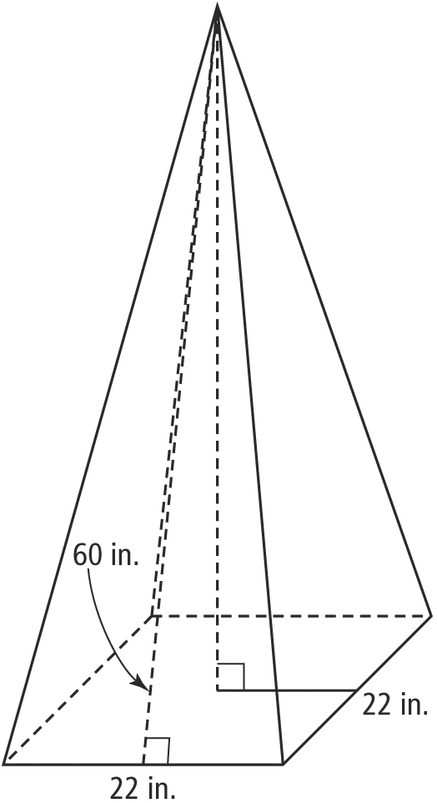
c) 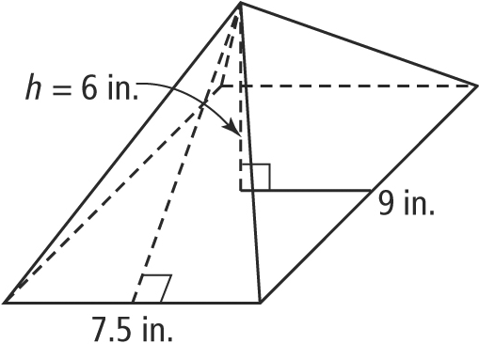
6. Determine the surface area of each 3-D object. Round the answer to the nearest tenth of a square unit.
a) 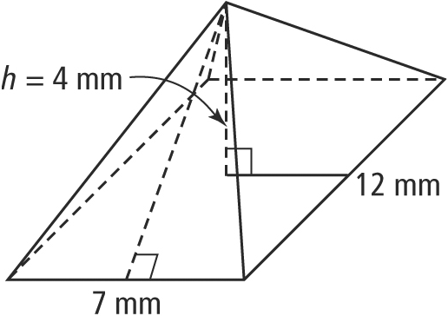
b) 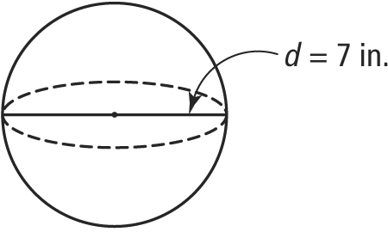
7. The surface area is given for each 3-D object. To the nearest tenth of a square unit, determine the missing dimension.
a) 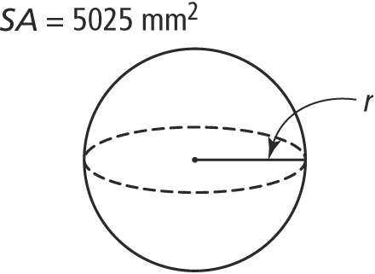
b) 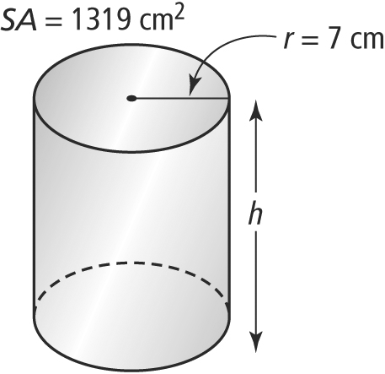
c) 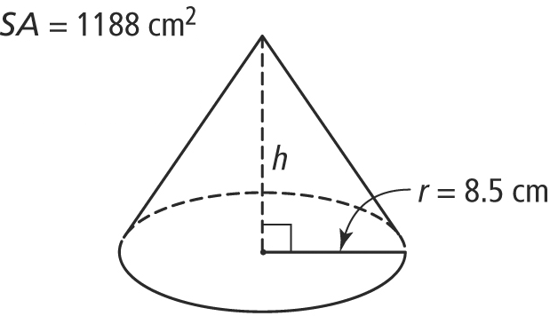
8. A dome-shaped tent has a diameter of 9 ft. How much material is needed to make the tent, to the nearest tenth of a square foot? Hint: A dome is half a sphere.
9. Jake and his father installed a wall light beside the front door of their home. The wall light consists of a wooden box with a round plastic cover for the light to shine through. Once the wall light is in place, Jake decides to paint the wooden part to contrast with the front of the house. What area will Jake need to paint? Give your answer to the closest tenth of a square inch.
