Section 2.3 Extra Practice

1. Determine the volume of each 3-D object. Round each answer to the nearest tenth of a cubic unit.
a) 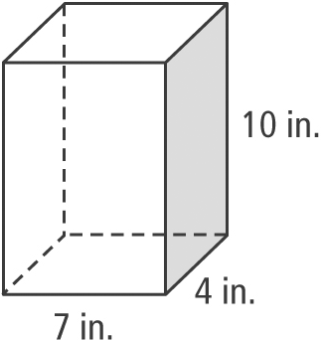
b) 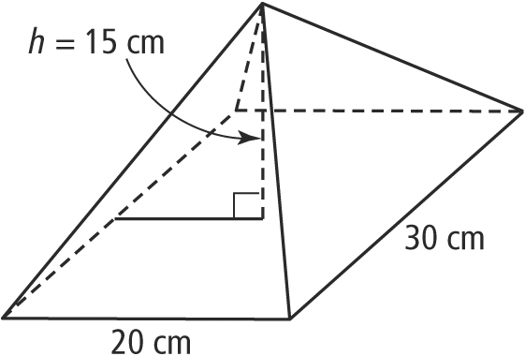
c) 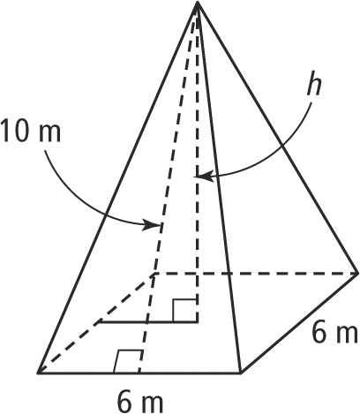
d) 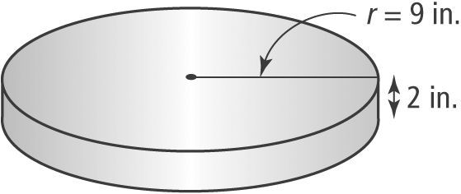
e) 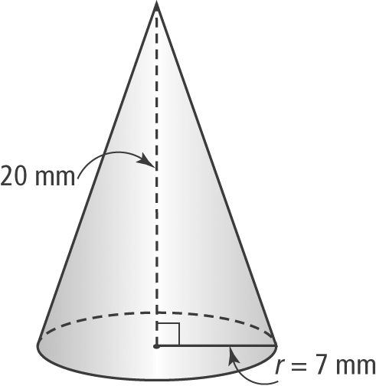
f) 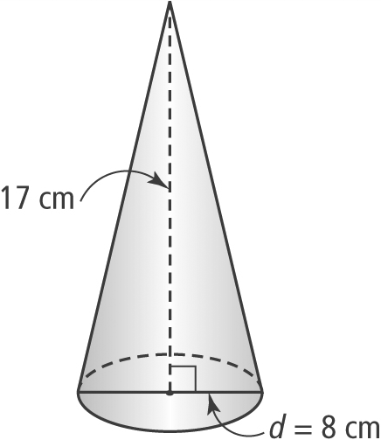
2. A microwave oven has a capacity of 1 ft³. The interior of the microwave is
14 in. wide and 14 in. deep. What is the height of the interior of the microwave?
3. Determine the volume of the globe.
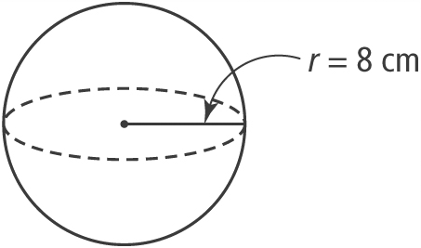
4. A beach ball holds 804 in.³ of air. Determine the diameter of the beach ball.
5. Draw and label a diagram of each shape, then calculate the missing dimension.
a) A cylinder has a volume of and a radius of 0.8 m. What is the height of the cylinder?
b) A cylinder has a volume of and a height of 11 cm. What is its radius?
c) A cone has a height of 3 ft and a volume of . Determine its radius.
d) A cone has a radius of 23 cm and a volume of . What is the height of the cone?
6. Calculate the volume, in cubic feet, of a sphere with a diameter of 1'3".
7. Frank made a model of a house in construction class. The block of wood for the base measures 3 in. by 2 in. and is 2 in. tall. He used a triangular prism for the roof that hangs over the base half an inch on all sides and is 1in. in height. Calculate the total volume of wood used for the model.
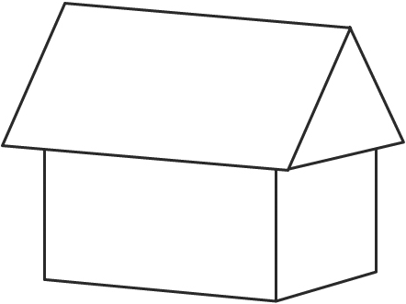
8. A perfume bottle shaped like a pyramid is 5" tall.
a) The top is a sphere with a volume of . What is the diameter of the sphere?
b) Assume that the apex of the pyramid touches the base of the sphere. What is the height of the pyramid?
c) If the volume of the pyramid is and the length of the base is 3 in., determine the width of the rectangular base.
d) Using the dimensions you have calculated, determine the volume of the rectangular-shaped box needed to package the bottle of perfume.
