Chapter 3 BLM Answers

BLM 3−2 Chapter 3 Prerequisite Skills
1. ∠3
2. Example: ∠1 = 60°, ∠2 = 75°,
∠3 = 105°, ∠4 = 50°, ∠5 = 120°
3. Example:

a)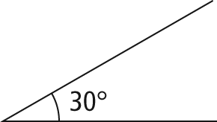 | b) 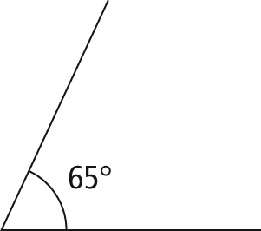
c) 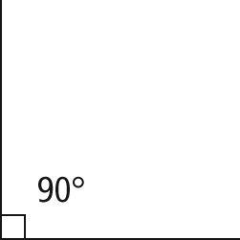 | d) 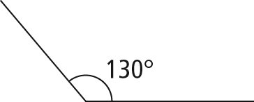
4. 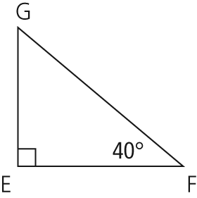

5. a) side f b) 40° c) side f d) ∠EFD or ∠DFE
6. The triangle could be sketched in two ways. The shortest side, PQ, is opposite the smallest angle. As a result, the 30° angle is labelled R in both sketches. However, side PQ could be labelled with either the P or the Q at the right angle.
7. a) x² = 6² + 9² b) x² = 9² − 7² or 9² = x² + 7²
c) y² = 5² − 2² or 5² = y² + 2²
8. a) x = 5 b) x = 5 c) x = 12
9. Sets can be arranged in several ways. Possible explanations include
- arranged by shape (circles, rectangles, and triangles)
- arranged by size (small and large)
- arranged by orientation (horizontal/vertical and rotated)
- arranged as “similar figures” mathematically (two circles, two right triangles, two equilateral triangles, or the two rectangles where the length is slightly more than twice the width)
10. a) and ∠A = ∠D,
∠B = ∠E, and ∠C = ∠F
b) AB : DE, AC : DF, and BC : EF c) x = AC
11. a) 14 b) 5
BLM 3−3 Chapter 3 Warm-Up
Section 3.1
1. a) 9.8 b) 7.9 c) 6.6
2. a) ∠E = 40° b) ∠F = 67° c) ∠C = 45°
3. a) AE b) HF c) JC 4. D
5. a) 15 b) 9 c) 18.75
Section 3.2
1. a) 0.933 b) 3.078 c) 1.732
2. a) 14° b) 69° c) 22°
3. a) 11.2 b) 12.9 c) 52.0 d) 17.3
4. a) AD b) BH c) JG
5. a) 5.8 b) 4.2
Section 3.3
1. a) 0.682 b) 0.731 c) 0.933
2. a) 22° b) 68° c) 21°
3. a) 8.2 b) 12.6
4. a) DE b) BF c) CG
5. a) 18° b) 7.7
BLM 3−5 Section 3.1 Extra Practice
1. a) 10 = hypotenuse, 8 = opposite, 6 = adjacent b) c = hypotenuse, a = opposite, b = adjacent
2. a) 0.5774 b) 0.2126 c) 1.1106 d) 5.6713
3. a) 31° b) 9° c) 57° d) 84°
4. a) 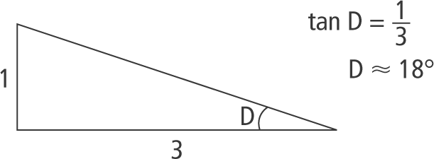
b) 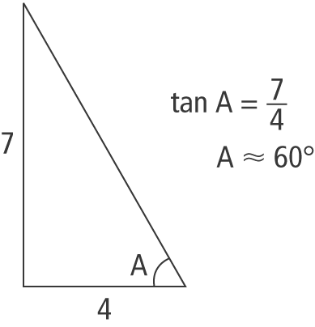
5. a) 4.5 cm b) 7.9 cm 6. a) 36° b) 58°
7. 9.3 m 8. 49°
BLM 3−7 Section 3.2 Extra Practice
1. a) b) c) d)
2. a) 0.5736 b) 0.9781 c) 0.9781 d) 0.0872
3. a) 53° b) 81° c) 27° d) 47°
4. a) 6.1 b) 5.8 c) 16.4 d) 4.4 m
5. a) 34° b) 60° c) 41° d) 26°
6. 80.3 m 7. 17°
BLM 3−8 Section 3.3 Extra Practice
1. a) b = 8.5
b) e = 4.8, d = 7.6
c) h = 22.9, i = 7.8
d) k = 8.5
2. a) 76° b) 2.2 cm
3. a) 60.2 m b) c) Yes, he can, because the distance to the nest is only 68.2 m.
4. 61°
BLM 3−9 Chapter 3 Test
1. B 2. A 3. B 4. C
5. a) 0.7986 b) 0.8829 c) 0.5774
6. a) 35° b) 22° c) 60°
7. 1 8. 19.5° 9. 69° 10. 22 ft
11. θ = 25°, x = 18.6 cm, y = 39.9 cm
12. a) b) 107.9 m c) 128.6 m
13. a) left side Example: The light grey angle represents the angle of elevation from Nicole to the right side of the building (40°), and the dark grey angle represents the angle of elevation from Nicole to the left side of the building (68°). From the diagram, Nicole must be on the left side of the building.
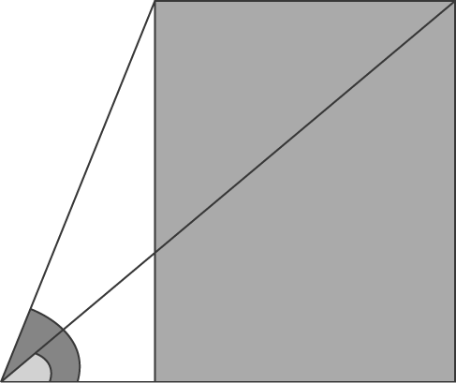
b) 9.9 m

