Chapter 3 Unit 1 Project
Section 3.1
1. A satellite radio cell tower provides signals to three substations, T1, T2, and T3. The three substations are each located along a stretch of the main road. The cell tower is located 24 km down a road perpendicular to the main road. A surveyor calculates the angle from T1 to the cell tower to be 64º, from T2 to the cell tower to be 33º, and from T3 to the cell tower to be 26º. Calculate the distance of each substation from the intersection of the two roads. Express your answers to the nearest tenth of a kilometre.
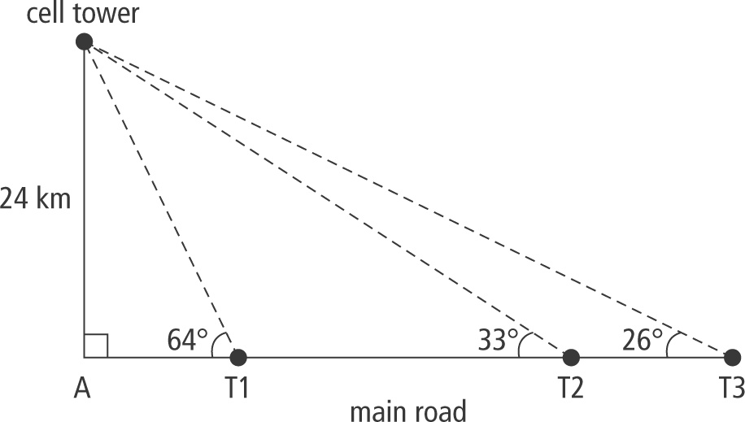
2. The first sound recordings were done on wax cylinders that were 5 cm in diameter and 10 cm long. Wax cylinders were capable of recording about 2 min of sound. Modern music storage devices can have tremendous memory and store thousands of songs. Janine calculated the number of wax cylinders needed to match a 32 GB storage capacity. Imagine that these cylinders are stacked one on top of another. From a distance of 10 m, the angle of elevation to the top of the stack would be 89.5º.
a) Draw and label a diagram to represent the situation.
b) Determine the height of the stack of cylinders, to the nearest hundredth of a metre.
c) How many cylinders would need to be stacked to match 32 GB of storage?
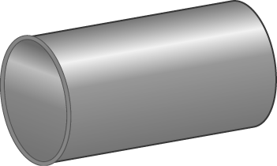
Section 3.3
3. A cell phone can be used to send music, but as your location changes, you move in and out of range from one cell to the next. Three or more cellular towers may pick up a cell phone’s signal. A cell phone signal has been located 5 mi from tower 1.
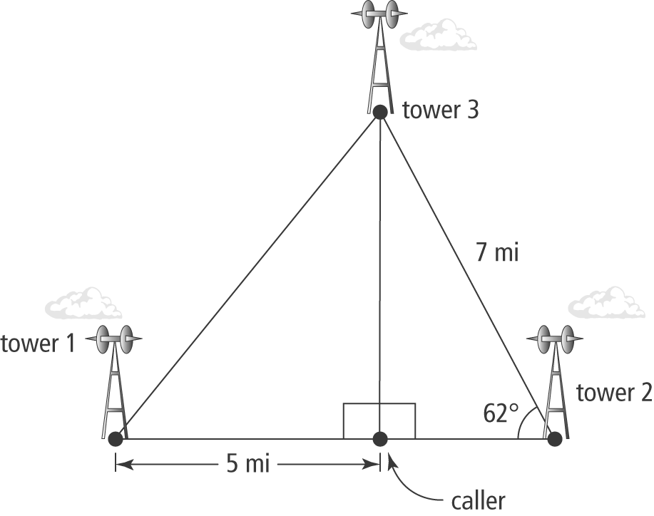
a) What is the distance from the caller to tower 3?
b) How far is tower 1 from tower 3?

